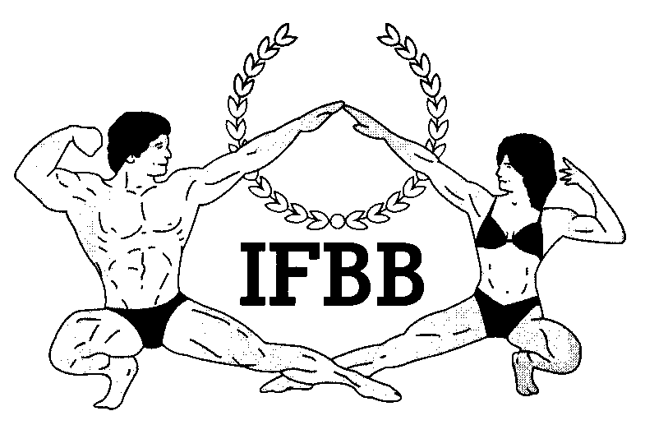
International Federation of Bodybuilding & Fitness
Dublin 39/I – Europolis – Las Rozas - Madrid – 28232 – Spain - Tel: (34) 5352819 Fax: (34) 5351518
E-mail: headquarters@ifbb.com Website: www.ifbb.com

FINAL ENTRY FORM

Deadline date to send the Entry Form is OCTOBER 2nd, 2018.
I F B B N O R D I C C U P O C T O B E R 5 - 7 , 2 0 1 8 L A H T I , F I N L A N D

COUNTRY |  | PRESIDENT NAME | FEDERATION NAME
CONTACT No FEDERATION (OFFICE OR CELL PHONE) |  |  | EMAIL FEDERATION
 | If applicable: Responsible Delegate(s) name at this event |  |  |  | Cell phone |  | PASSPORT NR
1
ENTRY TO THIS EVENT IS UNLIMITED, BUT HAS TO BE APPROVED BY THE NATIONAL FEDERATION
Save this form on your computer and fill in the names and categories. Please leave it in WORD format, so we can copy/paste the athletes’ names on our list. Please DO NOT change it to PDF format.
 | Competitor:  1 Given name + 1 Family name |  |  | CATEGORY |  | IFBB IC or PASSPORT NR
1
2
3
4
5
6
7
8
9
10
11
12
13

IF YOU HAVE MORE ATHLETES AND/OR DELEGATES, PLEASE ADD THEM ON A SEPERATE PAGE OR COPY THE PAGE ABOVE.
ALL THE COSTS FOR TRAVELLING, HOTEL ACCOMMODATIONS AND MEALS (AND TRANSPORT FROM AND TO THE AIRPORT) MUST BE COVERED BY THE NATIONAL FEDERATIONS. HOTEL RESERVATION MUST BE DONE BY DIRECT COMMUNICATION BETWEEN WITH THE OFFICIAL HOTELS. THE ORGANIZING COMMITTEE OR IFBB WILL NOT BE RESPONSIBLE FOR ANY RESERVATION OR PAYMENT OF HOTEL ACCOMMODATIONS, TRAVELING ARRANGEMENTS AND MEALS.

IMPORTANT NOTES:
The Organizer of the event in LAHTI, FINLAND, will not accept any direct registration from athletes. Entry Forms with athlete names will only be considered if they are sent by the National Federation of the athlete and directly to IFBB Headquarters in Madrid and IFBB Technical Commission (see email addresses below). The final decision to allow an athlete to compete in this event rests with the IFBB.

Registration fee is EUR €200 per athlete and will have to be paid at the registration desk on the arrival day. Registration will start on Friday from 16:00 to 20:00 hrs. (from 4 pm to 8 pm).
The categories accepted for the above mentioned championships are:
Men´s Bodybuilding Up to and incl. 80 kg Up to and incl. 90 kg Up to and incl. 100 kg Over 100 kg  Overall Winner (IFBB Elite Pro Card)  Men's Physique  Up to and incl. 173 cm Up to and incl. 179 cm Over 179 cm  Overall Winner (IFBB Elite Pro Card)  Muscular Men’s Physique, open class  Classic Bodybuilding Up to and incl. 180 cm Over 180 cm  Overall Winner (IFBB Elite Pro Card) | Women’s Bodyfitness Up to and incl 163 cm Up to and incl 168 cm Over 168 cm  Overall Winner (IFBB Elite Pro Card) Masters 35 year and over  Women’s Bikini-Fitness Up to and incl. 160 cm Up to and incl. 164 cm Up to and incl. 169 cm Up to and incl. 172 cm Over 172 cm  Overall Winner (IFBB Elite Pro Card) Masters 35 year and over  Women’s Wellness Fitness  Up to and incl. 158 cm Up to and incl. 164 cm Up to and incl. 168 cm Over 168 cm  Overall Winner (IFBB Elite Pro Card)
Please send Entry Form no later than October 2nd, 2018 to: (Preferably by email)

IFBB HEAD OFFICE
Email: info@ifbb.com

And
IFBB Technical Committee Mr. Andrew Michalak
Email: amichalak5@gmail.com

NOMINATION OF JUDGES
NAME: CELL PHONE
Please Send a copy to: Mr. KP Ourama
Organizer of IFBB Nordic Cup
Nordic Fitness Expo
Email: kpourama@kpfitness.fi
E-MAIL ADDRESS

Arrival / departure details:
ARRIVAL DATE | AIRLINE | FLIGHT No | TIME | DEPARTURE DATE | AIRLINE | FLIGHT No | TIME

