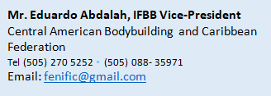

48th Central American And Caribbean Championship of Bodybuilding and
Fitness 2021.
SAN SALVADOR, EL SALVADOR
12th to 16th August 2021.

In order to assist in the planning and organization of these Championships, please complete the
Preliminary Entry Form and return it to the Organizing Committee.
AS SOON AS POSSIBLE, BUT NO LATER THAN 1st July 2021.

Country Name: Contact Person:
Fax Number: Email address:

Our Federation is planning to participate in these Championships: YES or NO

Estimated number of competitors:

Estimated number of delegates:

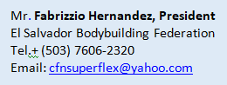
Estimated number of supporters:

