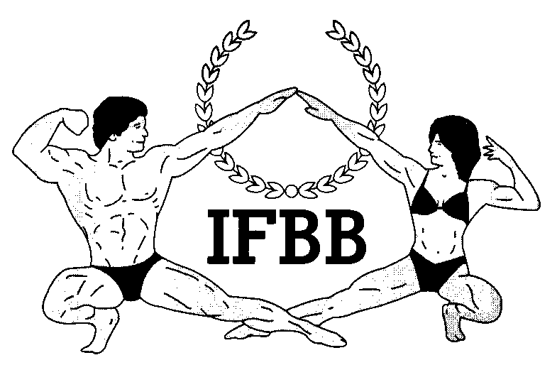

International Federation of Bodybuilding & Fitness
Dublin 39/I – Europolis – Las Rozas - Madrid – 28232 – Spain - Tel: (34) 5352819 Fax: (34) 5351518
E-mail: headquarters@ifbb.com Website: www.ifbb.com

FINAL ENTRY FORM

2022 IFBB NORWAY GRAND PRIX
April 22nd - 24th, 2022 – HAMAR, NORWAY
IFBB RANKING EVENT; ELITE PRO QUALIFIER
Deadline date to send the Final Entry Form is Monday, April 11th, 2022
This Entry Form is to be completed and sent by National Federations, NOT by individual athletes
It is full responsibility and obligation of the National Federation to verify if each one of the athletes to be registered on this international event are NOT SUSPENDED or fulfilling any period of ineligibility due to Anti-Doping Rule Violation or any disciplinary case at national or international level.

COUNTRY |  | NATIONAL FEDERATION’S NAME |  |  |  | NF PRESIDENT’S NAME
FEDERATION CONTACT NO. (OFFICE OR CELL PHONE) |  |  |  | NATIONAL FEDERATION’S E-MAIL ADDRESS
 | If applicable: Responsible Delegate(s) name at this event |  |  |  | Cell phone |  | PASSPORT No.
1
2
Complete this Form in ENGLISH LETTERS and leave it in the WORD format, so we can copy/paste the athletes’ names on our list. DO NOT change it to PDF format, please.
 | Competitor’s:  1 Given NAME + 1 Family NAME |  | CATEGORY  According to the List of Categories below |  |  |  | IFBB IC or  PASSPORT NR
1
2
3
4
5
6
7
8
9
10
11
12
13
IF YOU HAVE MORE ATHLETES, CONTINUE THIS TABLE, PLEASE.
IMPORTANT NOTES:
ALL THE COSTS FOR TRAVELLING, HOTEL ACCOMMODATIONS AND MEALS (AND TRANSPORT FROM AND TO THE AIRPORT) MUST BE COVERED BY NATIONAL FEDERATIONS. HOTEL RESERVATION MUST BE DONE BY DIRECT COMMUNICATION BETWEEN THE NATIONAL FEDERATION AND THE HOTELS. CHECK WITH YOUR NATIONAL FEDERATION FOR MORE INFORMATION.

The Organizer of the event in Norway will not accept any direct registration from athletes.
This Final Entry Form will only be considered if it is sent by the National Federation of the athlete and directly to the Organizer, IFBB Headquarters in Madrid and IFBB Technical Committee (see email addresses below). The final decision to allow an athlete to compete in this event rests with the IFBB.

Registration fee is EUR €200 per athlete and will have to be paid in advance by credit/debit card or PayPal at IFBB webpage http://www.ifbb.com/competition-registration/.
Please add your name during online payment and bring a copy of your payment confirmation to the registration. The online payment system will be switched off on Tuesday, April 12th, 24:00 (midnight, CEST). If paying at the Registration on April 22nd, 2022, it will be EUR €250 per participant. Additional categories: EUR €100 will be charged per each of the additional categories.

Categories accepted in the 2022 IFBB NORWAY GRAND PRIX:
MEN’S BODYBUILDING
UP TO & INCLUDING 85 kg
UP TO & INCLUDING 100 kg
OVER 100 kg
OVERALL – Elite Pro Card for the overall winner

MASTER MEN’S BODYBUILDING >40 YRS – OPEN
Master Elite Pro Card for the winner

MEN’S CLASSIC PHYSIQUE* – OPEN
Elite Pro Card for the winner

MEN’S CLASSIC BODYBUILDING*
UP TO & INCLUDING 180 cm
OVER 180 cm
OVERALL – Elite Pro Card for the overall winner
MEN’S PHYSIQUE
UP TO & INCLUDING 173 cm
UP TO & INCLUDING 179 cm
UP TO & INCLUDING 182 cm
OVER 182 cm
OVERALL – 2 Elite Pro Cards for the overall winners
JUNIOR MEN’S PHYSIQUE 16-23 YEARS – OPEN

MASTER MEN’S PHYSIQUE >40 YRS – OPEN

WOMEN’S BODYFITNESS
UP TO & INCLUDING 163 cm
OVER 163 cm
OVERALL – Elite Pro Card for the winner
MASTER WOMEN’S BODYFITNESS (>35 YRS) - OPEN
Master Elite Pro Card for the winner
WOMEN’S BIKINI
UP TO & INCLUDING 158 cm
UP TO & INCLUDING 160 cm
UP TO & INCLUDING 164 cm
UP TO & INCLUDING 169 cm
UP TO & INCLUDING 172 cm
OVER 172 cm
OVERALL – 2 Elite Pro Cards for the overall winners
JUNIOR WOMEN’S BIKINI 16-23 YEARS - OPEN

MASTERS WOMEN’S BIKINI >35 YEARS – OPEN
Master Elite Pro Card for the winner

WELLNESS
UP TO & INCLUDING 163 cm
OVER 163 cm
OVERALL – Elite Pro Card for the overall winner

WOMEN’S WOMEN’S PHYSIQUE – OPEN
Master Elite Pro Card for the winner

.

Please send this Entry Form no later than  April 11th, 2022 to:  Italian Bodybuilding & Fitness Federation  President, Ms. Elise Murbaeck  E-mail: signup@ifbbnorway.no  IFBB Technical Committee  Eng. Andrew Michalak  E-mail: amichalak5@gmail.com | Please send a copy to:  International Federation of Bodybuilding and Fitness  Head Office:  Ms. Vanessa Leon  E-mail: contact@ifbb.com

Please list your IFBB INTERNATIONAL JUDGES coming to this event:
 | NAME (AS WRITTEN IN PASSPORT) | PASSPORT NUMBER
1
2

Date of issue:

Completed by (your name & position in the NF):

