FINAL ENTRY FORM

|  |
| --- |
| **IFBB CLASSIC PHYSIQUE OF AMERICA CUP 2022**  **July 16 to 17, 2022.**  **Guayaquil, Ecuador** |

**The deadline to send the final registration form is Monday, July 11, 2022**

**This Entry Form must be completed and sent by the National Federations.**

It is the entire responsibility and obligation of the National Federation to verify if each of the athletes to register for this international event ARE NOT SUSPENDED or serving any period of disqualification for an Anti-Doping Rule Violation or any disciplinary case at the national or international level.

|  |  |  |  |  |  |  |
| --- | --- | --- | --- | --- | --- | --- |
| **COUNTRY** | | **NAME OF THE NATIONAL FEDERATION** | | | | **NAME OF THE PRESIDENT OF NF** |
|  | |  | | | |  |
| **FEDERATION CONTACT NUMBER (OFFICE OR CELL PHONE)** | | | | **EMAIL ADDRESS OF THE NATIONAL FEDERATION** | | |
|  | | | |  | | |
|  | **NAME OF THE DELEGATE (S) RESPONSIBLE AT THIS EVENT** | | | **CELL PHONE** | **PASSPORT NO.** | |
| **1**  **2** |  | | |  |  | |
| **Please complete this Form in ENGLISH LETTERS and leave it in WORD format, so we can copy/paste the names of the athletes on our list. Please DO NOT change it to PDF format.** | | | | | | |
|  | **Competitor’s:**  **1 Given** NAME + 1 **Family** NAME | | **MODALITY AND DIVISION :**  *(According to the list of categories below)* | | **PASSPORT No.** | |
| **1** |  | |  | |  | |
| **2** |  | |  | |  | |
| **3** |  | |  | |  | |
| **4** |  | |  | |  | |
| **5** |  | |  | |  | |
| **6** |  | |  | |  | |
| **7** |  | |  | |  | |
| **8** |  | |  | |  | |
| **9** |  | |  | |  | |
| **10** |  | |  | |  | |
| **11** |  | |  | |  | |
| **12** |  | |  | |  | |
| **13** |  | |  | |  | |
| **14** |  | |  | |  | |
| **15** |  | |  | |  | |
| **16** |  | |  | |  | |

**Possible crossovers:**

Classic Bodybuilding– Classic Physique – Bodybuilding

Bikini Fitness – Women’s Fit Model

Men’s Fitness– Men’s Physique

Women’s Acrobatic Fitness– Women’s Bodyfitness

Wellness Fitness – Women’s Fit-Model

Junior y Masters – Senior

**CATEGORIES OPEN AT THE IFBB CLASSIC PHYSIQUE OF AMERICA CUP 2022:**

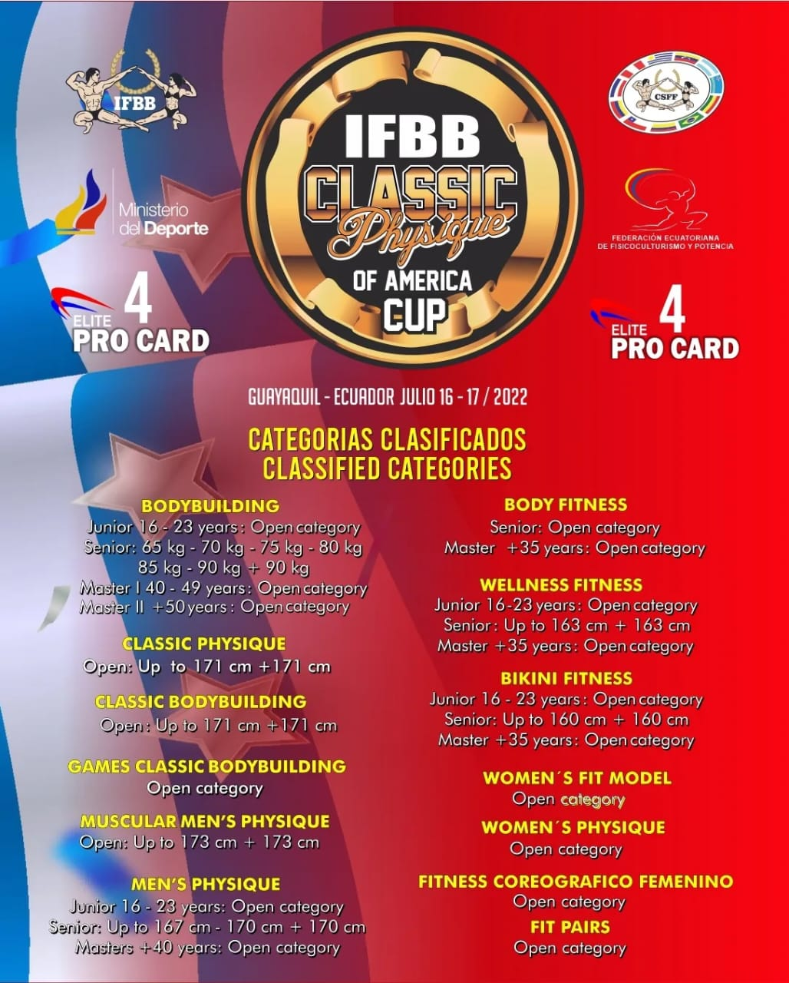

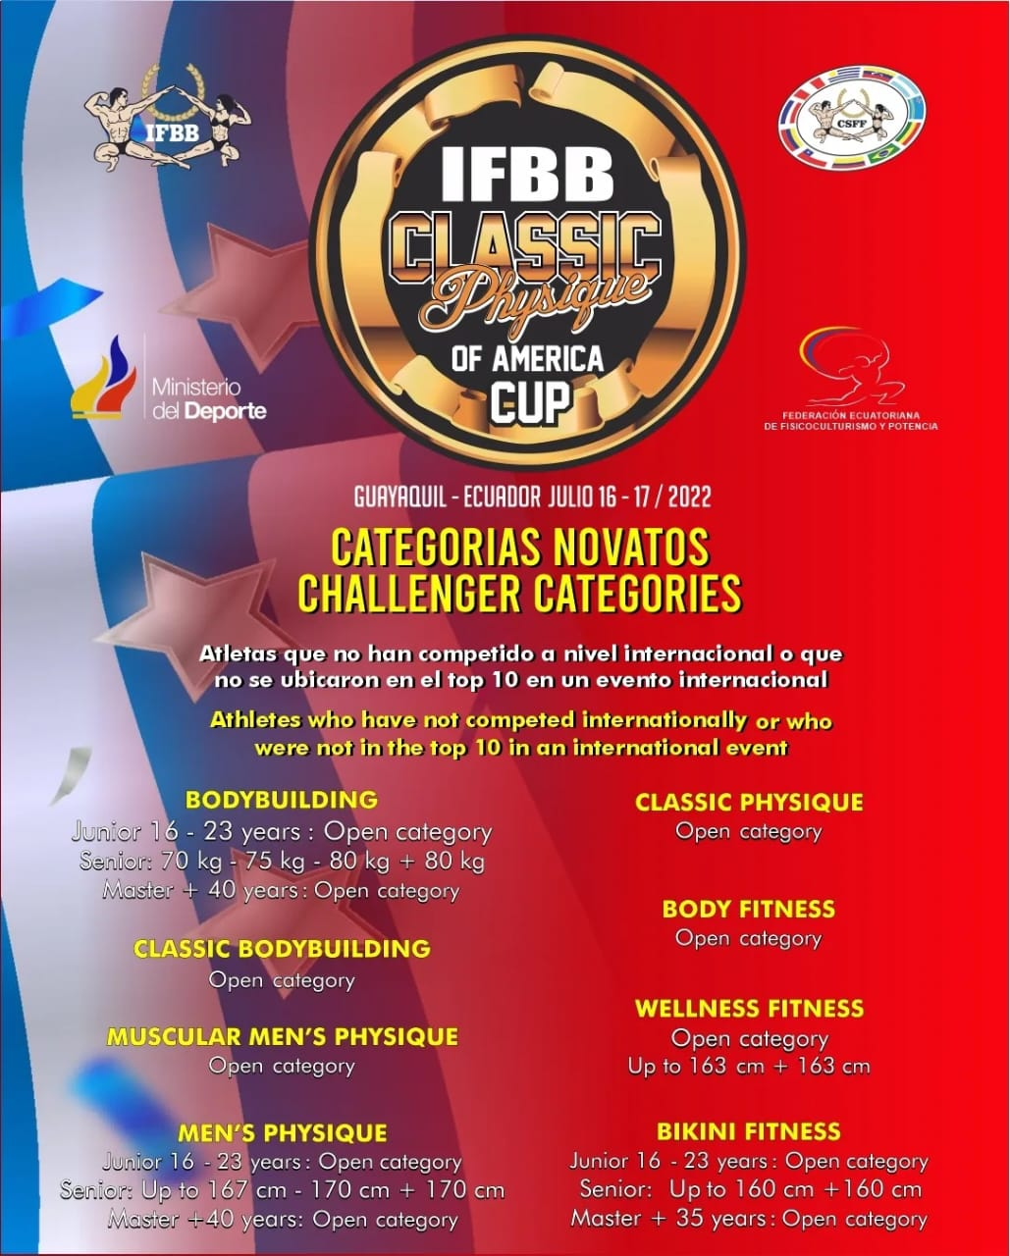



|  |
| --- |
| **Please send this Entry Form no later than July 11, 2022.** |
| **Comité organizador:** |
| Confederación Sudamericana de Fisicoculturismo y Fitness CSFF |
| Teléfono: + 593 999614465 |
| E-mail: [csff.ifbb@gmail.com](mailto:csff.ifbb@gmail.com) |