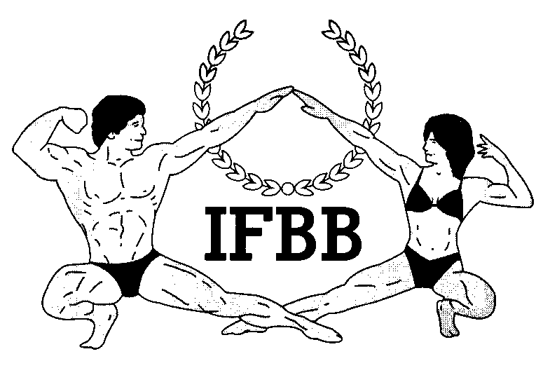

International Federation of Bodybuilding & Fitness

Dublin 39/I – Europolis – Las Rozas - Madrid – 28232 – Spain - Tel: **(34) 5352819** Fax: **(34) 5351518**

E-mail: [headquarters@ifbb.com](mailto:headquarters@ifbb.com) Website: [www.ifbb.com](http://www.ifbb.com)

FINAL ENTRY FORM

|  |
| --- |
| **2022 IFBB FLORIDA CLASSIC**  **June 25th – 27th, 2022 – MIAMI, FLORIDA - USA**  ***IFBB RANKING EVENT; ELITE PRO QUALIFIER*** |

**Deadline date to send the Final Entry Form is Monday, June 13th, 2022**

***This Entry Form is to be completed and sent by National Federations, NOT by individual athletes***

***It is full responsibility and obligation of the National Federation to verify if each one of the athletes to be registered on this international event are NOT SUSPENDED or fulfilling any period of ineligibility due to Anti-Doping Rule Violation or any disciplinary case at national or international level.***

|  |  |  |  |  |  |  |  |
| --- | --- | --- | --- | --- | --- | --- | --- |
| **COUNTRY** | | **NATIONAL FEDERATION’S NAME** | | | | **NF PRESIDENT’S NAME** | |
|  | |  | | | |  | |
| **FEDERATION CONTACT NO. (OFFICE OR CELL PHONE)** | | | | **NATIONAL FEDERATION’S E-MAIL ADDRESS** | | | |
|  | | | |  | | | |
|  | **If applicable: Responsible Delegate(s) name at this event** | | | | **Cell phone** | | **PASSPORT No.** |
| 1  2 |  | | | |  | |  |
| **Complete this Form in ENGLISH LETTERS and leave it in the WORD format, so we can copy/paste the athletes’ names on our list. DO NOT change it to PDF format, please.** | | | | | | | |
|  | **Competitor’s:**  **1 Given** NAME + 1 **Family** NAME | | **CATEGORY**  *(According to the list of categories below)* | | | | **IFBB IC or**  **PASSPORT NR** |
| **1** |  | |  | | | |  |
| **2** |  | |  | | | |  |
| **3** |  | |  | | | |  |
| **4** |  | |  | | | |  |
| **5** |  | |  | | | |  |
| **6** |  | |  | | | |  |
| **7** |  | |  | | | |  |
| **8** |  | |  | | | |  |
| **9** |  | |  | | | |  |
| **10** |  | |  | | | |  |
| **11** |  | |  | | | |  |
| **12** |  | |  | | | |  |
| **13** |  | |  | | | |  |

***IF YOU HAVE MORE ATHLETES, CONTINUE THIS TABLE, PLEASE.***

**IMPORTANT NOTES:**

**ALL THE COSTS FOR TRAVELLING, HOTEL ACCOMMODATIONS AND MEALS (AND TRANSPORT FROM AND TO THE AIRPORT) MUST BE COVERED BY NATIONAL FEDERATIONS. HOTEL RESERVATION MUST BE DONE BY DIRECT COMMUNICATION BETWEEN THE NATIONAL FEDERATION AND THE HOTELS. CHECK WITH YOUR NATIONAL FEDERATION FOR MORE INFORMATION.**

**USA athletes must register directly with the American Physique Federation.**

**This Final Entry Form will only be considered if it is sent by the National Federation of the athlete and directly to the Organizer, IFBB Headquarters in Madrid and IFBB Technical Committee (see email addresses below). The final decision to allow an athlete to compete in this event rests with the IFBB.**

**Registration fee is USD $200 per athlete and will have to be paid in advance by credit/debit card or PayPal on IFBB webpage** [**http://www.ifbb.com/competition-registration/**](http://www.ifbb.com/competition-registration/)**. Please add your name during online payment and bring a copy of your payment confirmation to the registration. The online payment system will be switched off on Tuesday, June 14th, 2022, 24:00 (midnight, CEST = UTC +2). If paying after this date or at the Registration on**

**June 25th, 2022, it will be USD $250 per participant. Additional categories: an extra fee of USD $100 per each of the additional categories will be charged.**

**Possible crossovers: Classic Bodybuilding – Classic Physique – Bodybuilding; Acrobatic Fitness – Bodyfitness; Bikini – Fit-Model; Wellness – Fit-Model. Also Juniors & Masters in the senior categories.**

**The contest is open for all IFBB-affiliated National Federations worldwide.**

**Categories open at the 2022 IFBB Florida Classic:**

**MEN’S BODYBUILDING:**

UP TO & INCLUDING 70 kg

UP TO & INCLUDING 80 kg

UP TO & INCLUDING 90 kg

OVER 90 kg

*Elite Pro Cards for the top 2 overall winners*

**JUNIOR MEN’S BODYBUILDING 16-23 YRS - OPEN**

**MASTER MEN’S BODYBUILDING 40-49 YRS - OPEN**

**MASTER MEN’S BODYBUILDING >50 YRS - OPEN**

**MEN’S CLASSIC BODYBUILDING:**

UP TO & INCLUDING 175 cm

OVER 175 cm

*Elite Pro Card for the overall winner*

**MEN’S CLASSIC PHYSIQUE:**

UP TO & INCLUDING 175 cm

OVER 175 cm

*Elite Pro Cards for the top 2 overall winners*

**MASTER MEN’S CLASSIC PHYSIQUE >40 YRS – OPEN**

**MASTER CLASSIC BODYBUILDING > 40 YRS – OPEN**

**MEN’S PHYSIQUE:** UP TO & INCLUDING 175 cm

OVER 175 cm

*Elite Pro Cards for the top 2 overall winners*

**JUNIOR MEN’S PHYSIQUE 16-23 YRS - OPEN**

**MASTER MEN’S PHYSIQUE >40 YRS - OPEN**

**MUSCULAR MEN’S PHYSIQUE – OPEN**

**MIXED- PAIRS**

**WOMEN’S ACROBATIC FITNESS – OPEN**

**WOMEN’S ARTISTIC FITNESS - OPEN**

**WOMEN’S BODYFITNESS:**

UP TO & INCLUDING 163 cm

OVER 163 cm

*Elite Pro Cards for the overall winner*

**MASTER BODYFITNESS >40 YRS - OPEN**

**WOMEN’S BIKINI:**

UP TO & INCLUDING 160 cm

UP TO & INCLUDING 164 cm

UP TO & INCLUDING 168 cm

OVER 168 cm

*Elite Pro Cards for the top 2 overall winners*

**JUNIOR WOMEN’S BIKINI 16-23 YRS - OPEN**

**MASTER WOMEN’S BIKIN 35-39 YRS - OPEN**

**MASTER WOMEN’S BIKIN >40 YRS - OPEN**

**WOMEN’S WELLNESS:**

UP TO & INCLUDING 160 cm

UP TO & INCLUDING 166 cm

OVER 166 cm

*Elite Pro Cards for the top 2 overall winners*

**JUNIOR WOMEN’S WELLNESS 16-23 YRS – OPEN**

**MASTER WOMEN’S WELLNESS >35 YRS – OPEN**

**WOMEN’S PHYSIQUE - OPEN**

*Elite Pro Card for the winner*

**WOMEN’S FIT- MODEL – OPEN**

**FIT- PAIRS**

|  |  |
| --- | --- |
| **Please send this Entry Form no later than June 13th,2021 to:**  **Organizing Committee:  Ms. Carlos Cortez E-mail:** [carlos.cortes.fitness@gmail.com](carlos.cortes.fitness@gmail.com%20%20)  **IFBB Technical Committee**  **Eng. Andrew Michalak**  **E-mail:** [**amichalak5@gmail.com**](mailto:amichalak5@gmail.com) | **Please send a copy to:**  **International Federation of Bodybuilding and Fitness**  **Head Office: Ms. Vanessa León**  Phone: +34 91 535 2819   **E-mail:** [contact**@ifbb.com**](mailto:contact@ifbb.com) |

**Please list your IFBB INTERNATIONAL JUDGES designated to this event:**

|  |  |  |
| --- | --- | --- |
|  | **NAME (AS WRITTEN IN PASSPORT)** | **PASSPORT NUMBER** |
| 1 |  |  |
| 2 |  |  |
| 3 |  |  |

***Date of issue:***

***Completed by (****your name & position in the NF****):***