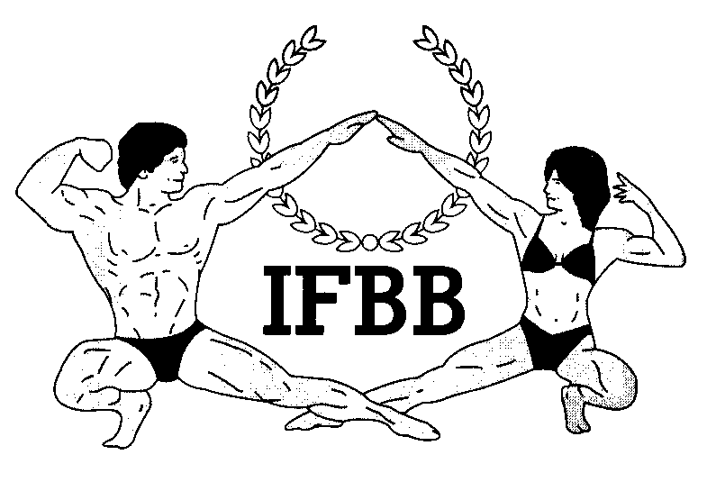

International Federation of Bodybuilding & Fitness
Dublin 39/I – Europolis – Las Rozas - Madrid – 28232 – Spain - Tel: (34) 5352819 Fax: (34) 5351518
E-mail: headquarters@ifbb.com Website: www.ifbb.com

FINAL ENTRY FORM

2022 IFBB FLORIDA CLASSIC
June 25th – 27th, 2022 – MIAMI, FLORIDA - USA
IFBB RANKING EVENT; ELITE PRO QUALIFIER
Deadline date to send the Final Entry Form is Monday, June 13th, 2022
This Entry Form is to be completed and sent by National Federations, NOT by individual athletes
It is full responsibility and obligation of the National Federation to verify if each one of the athletes to be registered on this international event are NOT SUSPENDED or fulfilling any period of ineligibility due to Anti-Doping Rule Violation or any disciplinary case at national or international level.

COUNTRY |  | NATIONAL FEDERATION’S NAME |  |  |  | NF PRESIDENT’S NAME
FEDERATION CONTACT NO. (OFFICE OR CELL PHONE) |  |  |  | NATIONAL FEDERATION’S E-MAIL ADDRESS
 | If applicable: Responsible Delegate(s) name at this event |  |  |  | Cell phone |  | PASSPORT No.
1
2
Complete this Form in ENGLISH LETTERS and leave it in the WORD format, so we can copy/paste the athletes’ names on our list. DO NOT change it to PDF format, please.
 | Competitor’s:  1 Given NAME + 1 Family NAME |  | CATEGORY  (According to the list of categories below) |  |  |  | IFBB IC or  PASSPORT NR
1
2
3
4
5
6
7
8
9
10
11
12
13

IF YOU HAVE MORE ATHLETES, CONTINUE THIS TABLE, PLEASE.
IMPORTANT NOTES:
ALL THE COSTS FOR TRAVELLING, HOTEL ACCOMMODATIONS AND MEALS (AND TRANSPORT FROM AND TO THE AIRPORT) MUST BE COVERED BY NATIONAL FEDERATIONS. HOTEL RESERVATION MUST BE DONE BY DIRECT COMMUNICATION BETWEEN THE NATIONAL FEDERATION AND THE HOTELS. CHECK WITH YOUR NATIONAL FEDERATION FOR MORE INFORMATION.

USA athletes must register directly with the American Physique Federation.
This Final Entry Form will only be considered if it is sent by the National Federation of the athlete and directly to the Organizer, IFBB Headquarters in Madrid and IFBB Technical Committee (see email addresses below). The final decision to allow an athlete to compete in this event rests with the IFBB.

Registration fee is USD $200 per athlete and will have to be paid in advance by credit/debit card or PayPal on IFBB webpage http://www.ifbb.com/competition-registration/. Please add your name during online payment and bring a copy of your payment confirmation to the registration. The online payment system will be switched off on Tuesday, June 14th, 2022, 24:00 (midnight, CEST = UTC +2). If paying after this date or at the Registration on
June 25th, 2022, it will be USD $250 per participant. Additional categories: an extra fee of USD $100 per each of the additional categories will be charged.

Possible crossovers: Classic Bodybuilding – Classic Physique – Bodybuilding; Acrobatic Fitness – Bodyfitness; Bikini – Fit-Model; Wellness – Fit-Model. Also Juniors & Masters in the senior categories.
The contest is open for all IFBB-affiliated National Federations worldwide.

Categories open at the 2022 IFBB Florida Classic:
MEN’S BODYBUILDING:
UP TO & INCLUDING 70 kg
UP TO & INCLUDING 80 kg
UP TO & INCLUDING 90 kg
OVER 90 kg
Elite Pro Cards for the top 2 overall winners

JUNIOR MEN’S BODYBUILDING 16-23 YRS - OPEN
MASTER MEN’S BODYBUILDING 40-49 YRS - OPEN
MASTER MEN’S BODYBUILDING >50 YRS - OPEN

MEN’S CLASSIC BODYBUILDING:
UP TO & INCLUDING 175 cm
OVER 175 cm
Elite Pro Card for the overall winner
MEN’S CLASSIC PHYSIQUE:
UP TO & INCLUDING 175 cm
OVER 175 cm
Elite Pro Cards for the top 2 overall winners

MASTER MEN’S CLASSIC PHYSIQUE >40 YRS – OPEN
MASTER CLASSIC BODYBUILDING > 40 YRS – OPEN

MEN’S PHYSIQUE:
UP TO & INCLUDING 175 cm
OVER 175 cm
Elite Pro Cards for the top 2 overall winners
JUNIOR MEN’S PHYSIQUE 16-23 YRS - OPEN
MASTER MEN’S PHYSIQUE >40 YRS - OPEN
MUSCULAR MEN’S PHYSIQUE – OPEN
MIXED- PAIRS

WOMEN’S ACROBATIC FITNESS - OPEN

WOMEN’S BODYFITNESS:
UP TO & INCLUDING 163 cm
OVER 163 cm
Elite Pro Cards for the overall winner

MASTER BODYFITNESS >40 YRS - OPEN

WOMEN’S BIKINI:
UP TO & INCLUDING 160 cm
UP TO & INCLUDING 164 cm
UP TO & INCLUDING 168 cm
OVER 168 cm
Elite Pro Cards for the top 2 overall winners

JUNIOR WOMEN’S BIKINI 16-23 YRS - OPEN

MASTER WOMEN’S BIKIN 35-39 YRS - OPEN

MASTER WOMEN’S BIKIN >40 YRS - OPEN

WOMEN’S WELLNESS:
UP TO & INCLUDING 160 cm
UP TO & INCLUDING 166 cm
OVER 166 cm
Elite Pro Cards for the top 2 overall winners

JUNIOR WOMEN’S WELLNESS 16-23 YRS – OPEN
MASTER WOMEN’S WELLNESS >35 YRS – OPEN
WOMEN’S PHYSIQUE - OPEN
Elite Pro Card for the winner

WOMEN’S FIT- MODEL – OPEN
FIT- PAIRS

Please send this Entry Form no later than June 13th, 2021 to:  Organizing Committee:  Ms. Carlos Cortez  E-mail: carlos.cortes.fitness@gmail.com  IFBB Technical Committee  Eng. Andrew Michalak  E-mail: amichalak5@gmail.com | Please send a copy to:  International Federation of Bodybuilding and Fitness  Head Office:  Ms. Vanessa León  Phone: +34 91 535 2819  E-mail: contact@ifbb.com

Please list your IFBB INTERNATIONAL JUDGES designated to this event:
 | NAME (AS WRITTEN IN PASSPORT) | PASSPORT NUMBER
1
2
3

Date of issue:

Completed by (your name & position in the NF):

