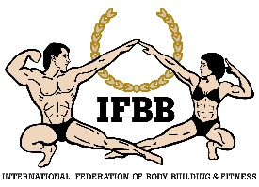

IFBB
PRELIMINARY ENTRY FORM

2022 IFBB WEST AFRICAN CHAMPIONSHIPS
July 13th to 16th, 2022 – ACCRA, GHANA
IFBB WORLD RANKING EVENT – LEVEL 2
IFBB ELITE PRO QUALIFIER

SEND THIS PEF AS SOON AS POSSIBLE, PLEASE, BUT NO LATER THAN WEDNESDAY, JUNE 20th 2022

Please notice that sending the PEF is MANDATORY.

Country:
Contact Person:
Phone/Mobile Number: E-mail address:

Our Federation is planning to participate in these competition: YES
Estimated number of competitors:
Estimated number of delegates:
Estimated number of supporters :
Send the Preliminary Entry Form to the following e-mail addresses, please:

Send this Entry Form no later than  Wednesday, June 01st, 2022 to:  ORGANIZING COMMITTEE  Ms. Christiana Ashley  E-mail: christianaashley1984@yahoo.com  Phone: 00. 233. 278. 22. 77. 77 or  Mobile: 00. 233. 554. 86. 59. 22 | Please, send a copy to:  International Federation of Bodybuilding and Fitness  Head Office:  Ms. Maria Sanson  E-mail: contactfbb.com  IFBB Technical Committee  Eng. Andrew Michalak  E-mail: amichalak5@gmail.com

Note, please, that each National Federation wishing to participate in these Championships must have paid the IFBB (EUR €500) affiliation fee for 2022. Otherwise, this Federation will not be allowed to participate. According to the IFBB Constitution, Art. 17, this fees should be paid in January of each year.

Date of issue:

Completed by (your name & position in the NF):

