International Federation of Bodybuilding & Fitness
Dublin 39/I – Europolis – Las Rozas - Madrid – 28232 – Spain - Tel: (34) 5352819 Fax: (34) 5351518
E-mail: headquarters@ifbb.com Website: www.ifbb.com
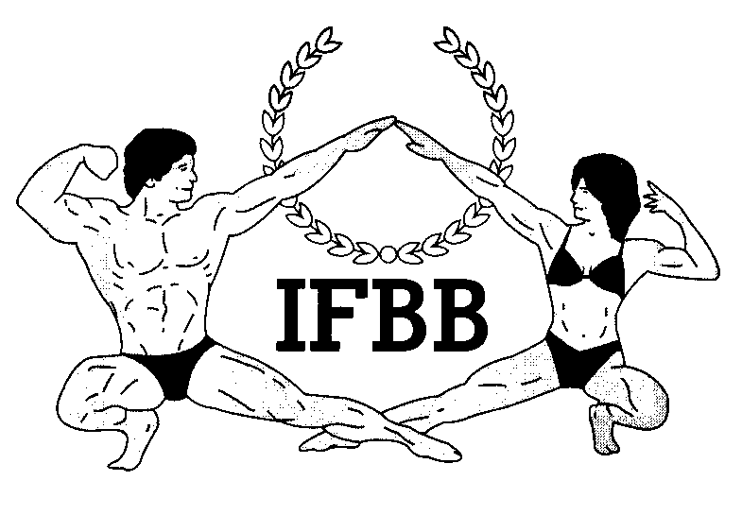

FINAL ENTRY FORM

2022 IFBB INTERNATIONAL STOCKHOLM CLASSIC SWEDEN
October 22nd 2022, STOCKHOLM – SWEDEN
OPEN TO ALL IFBB NORDIC ATHLETES (SWE, DEN, FIN, NOR, ICELAND)
Deadline date to send this Final Entry Form is October 7nd, 2022.
This Entry Form is to be completed and sent by National Federations, NOT by individual athletes
It is full responsibility and obligation of the National Federation to verify if each one of the athletes to be registered on this international event are NOT SUSPENDED or fulfilling any period of ineligibility due to Anti-Doping Rule Violation or any disciplinary case at national or international level.

COUNTRY |  | NATIONAL FEDERATION’S NAME |  |  |  | NF PRESIDENT’S NAME
NF’S CONTACT NO. (OFFICE OR CELL PHONE) |  |  |  | NATIONAL FEDERATION’S E-MAIL ADDRESS
 | If applicable: Responsible Delegate(s) names at this event |  |  |  | Cell phone |  | PASSPORT No.
1
2
Complete this Form in ENGLISH LETTERS and leave it in the WORD format, so we can copy/paste the athletes’ names on our list. DO NOT change it to PDF format, please.
 | Competitor’s:  1 Given NAME + 1 Family NAME |  | EXACT CATEGORY  (from the list of categories below) |  |  |  | IFBB Intern. Card  or PASSPORT No.
1
2
3
4
5
6
7
8
9
10
11
12
13
14
15
16

17
18

IF YOU HAVE MORE ATHLETES, CONTINUE THIS TABLE, PLEASE.
IMPORTANT NOTES:
ALL THE COSTS FOR TRAVELLING, HOTEL ACCOMMODATIONS AND MEALS (AND TRANSPORT FROM AND TO THE AIRPORT) MUST BE COVERED BY NATIONAL FEDERATIONS. HOTEL RESERVATION MUST BE DONE BY DIRECT COMMUNICATION BETWEEN THE NATIONAL FEDERATION AND THE HOTEL. CHECK WITH YOUR NATIONAL FEDERATION FOR MORE INFORMATION.

The Organizer of the event in SWEDEN will not accept only a direct registration from athletes, athletes needs to register to the national federation. So it is very important to register to your national federation to entry for Stockholm Classic.
This Final Entry Form will only be considered if it is sent by the National Federation of the athlete and directly to the Organizer, IFBB Headquarters in Madrid and IFBB Technical Committee (see email addresses below). The final decision to allow an athlete to compete in this event rests with the IFBB.

Registration fee is EUR €120 per athlete (crossovers EUR €60 extra) and will have to be paid in advance by credit/debit card at webpage http://sthlmclassic.com/sign-up . Please add your name during online payment and bring a copy of your payment confirmation to the registration. When your registration is done at the website you have the register at your national federation.
The online payment system will be switched off on October 7rd, 2022, 24:00 (midnight, CEST > UTC + 2 in summer).

Categories accepted at the 2022 IFBB Stockholm Classic Sweden:

MEN BODYBUILDING:
UP TO & INCLUDING 85 kg
OVER 85 kg
OVERALL (10.000 SEK PRICE MONEY)

JUNIOR MEN’S BODYBUILDING 16-23 YRS – OPEN

MEN’S CLASSIC BODYBUILDING:
UP TO & INCLUDING 178 cm
OVER 178 cm
OVERALL (4.000 SEK PRICE MONEY)
MEN’S CLASSIC PHYSIQUE:
UP TO & INCLUDING 178 cm
OVER 178 cm
OVERALL (6.000 SEK PRICE MONEY)

MEN’S PHYSIQUE
UP TO & INCLUDING 178 cm
OVER 178 cm
OVERALL (8.000 SEK PRICE MONEY)
JUNIOR MEN’S PHYSIQUE – OPEN

WOMEN’S BODYFITNESS – OPEN
UP TO & INCLUDING 163 cm
OVER 163 cm
OVERALL (4.000 SEK PRICE MONEY)

WOMEN’S BIKINI:
UP TO & INCLUDING 166 cm
OVER 166 cm
OVERALL (8.000 SEK PRICE MONEY)
JUNIOR WOMEN’S BIKINI – OPEN

WOMEN’S WELLNESS:
UP TO & INCLUDING 163 cm
OVER 163 cm
OVERALL (6.000 SEK PRICE MONEY

Possible crossovers:
Classic Bodybuilding - Classic Physique – Bodybuilding.

Bikini Fitness - Wellness Fitness.

Juniors in senior classes.

Note: A category will be run only if 5 or more athletes are registered. Otherwise, categories will be combined.

Please send this Final Entry Form no later than  October 7^{d}, 2022 to:  Organizing Committee  Mr Richard Susaeg  E‐mail: contact@sthlmclassic.com  SBFF  Jani Kaaria  E-mail: info@ifbbsweden.se | Please send a copy to:  International Federation of Bodybuilding and Fitness  Head Office:  E-mail: info@ifbb.com
Note, please, that each National Federation wishing to participate in this competition must have paid the IFBB (EUR €500) affiliation fee for 2022. Otherwise, this Federation will not be allowed to participate. According to the IFBB Constitution, Art. 17, this fees should be paid in January of each year.

Please list your TEST- JUDGES coming to this event:
 | NAME (AS WRITTEN IN PASSPORT) | PASSPORT NUMBER
1
2
3

Date of issue:

Completed by (your name & position in the NF):

