International Fitness & Bodybuilding Federation
Dublin 39/I – Europolis – Las Rozas - Madrid – 28232 – Spain - Tel: (34) 5352819
E-mail: headquarters@ifbb.com Website: www.ifbb.com

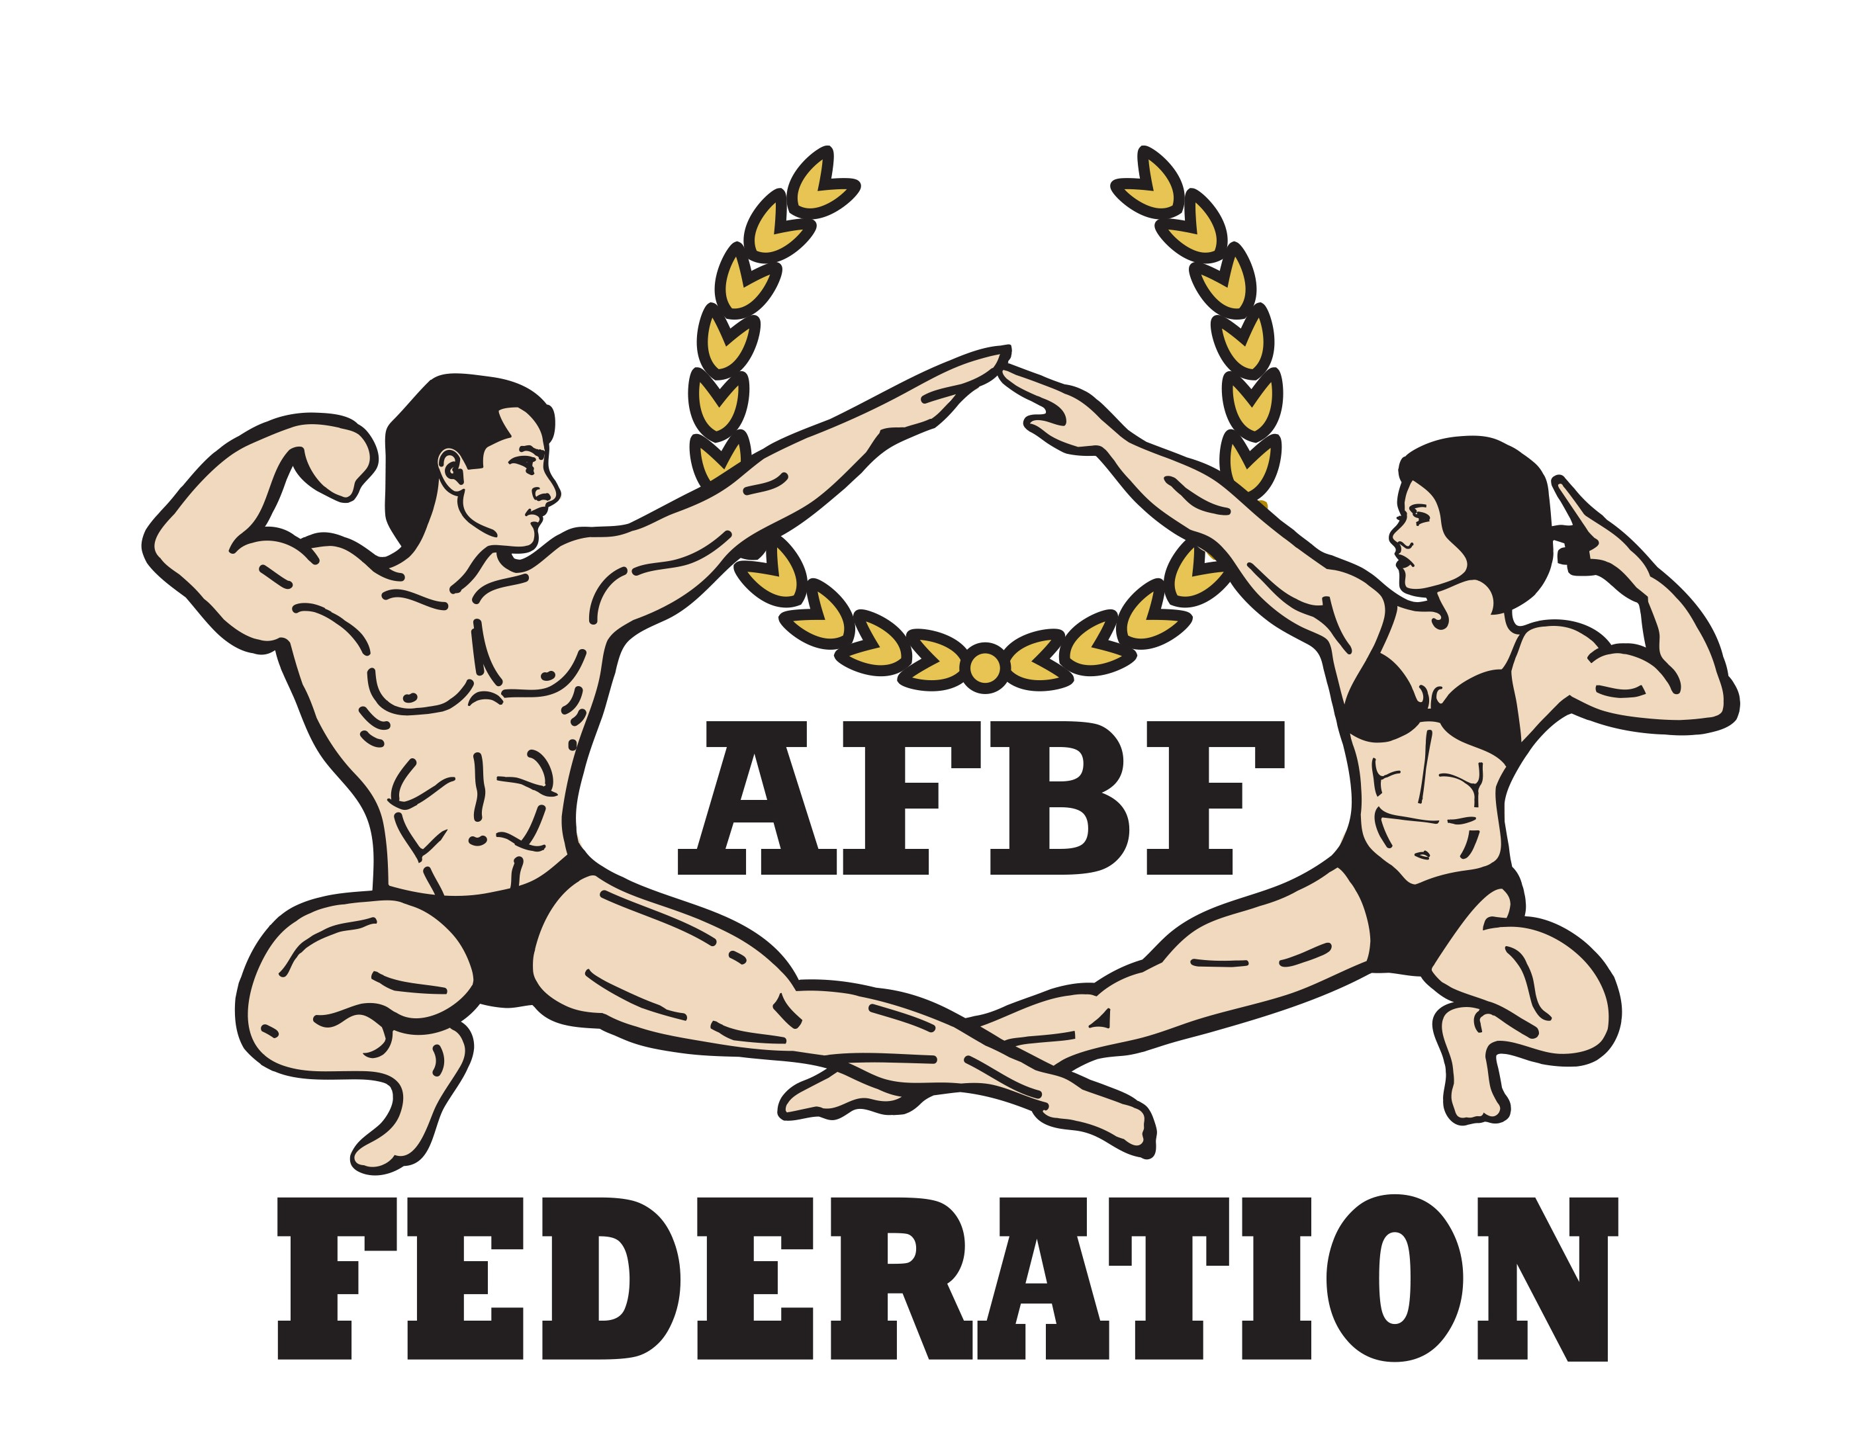


FINAL ENTRY FORM

Deadline date to send this Final Entry Form is Monday, October 09th, 2023
2023 IFBB MR. UNIVERSE AUSTRALIA
October 14th to 16th, 2023 - PERTH – WESTERN AUSTRALIA
IFBB WORLD RANKING EVENT; ELITE PRO QUALIFIER
This Entry Form is to be completed and sent by National Federations, NOT by individual athletes
It is full responsibility and obligation of the National Federation to verify if each one of the athletes to be registered on this international event are NOT SUSPENDED or fulfilling any period of ineligibility due to Anti-Doping Rule Violation or any disciplinary case at national or international level.

COUNTRY |  | NATIONAL FEDERATION’S NAME |  |  |  | NF PRESIDENT’S NAME
FEDERATION’S CONTACT NO. (OFFICE OR CELL PHONE) |  |  |  | NATIONAL FEDERATION’S E-MAIL ADDRESS
 | If applicable: Responsible Delegate(s) name at this event |  |  |  | Cell phone |  | PASSPORT No.
1
2
Complete this Form in English Letters and leave it in the WORD format, so we can copy/paste the athletes’ names on our list. DO NOT change it to PDF format, please.
 | Competitor’s  1 Given NAME + 1 Family NAME |  | EXACT CATEGORY  (from the list of available categories below) |  |  |  | IFBB IC or  PASSPORT No.
1
2
3
4
5
6
7
8
9
10
11
12
13
14
15
16

IF YOU HAVE MORE ATHLETES, CONTINUE THIS TABLE, PLEASE.

This Final Entry Form will only be considered if it is sent by the National Federation of the athlete and directly to the Organizing Committee, IFBB Head Office in Madrid and IFBB Technical Committee (see e-mail addresses below). The final decision to allow an athlete to compete in this event rests with the IFBB.

Registration Fee for athletes is AUD $200 per person and should be paid in advance by credit/debit card at www.cognitoforms.com/newsubmission/_2023omaraclassicmruniverserego
Please add your name during online payment and bring a copy of your payment confirmation to the registration. The online payment system will be switched off on October 10th, 2023, 23:50 (AWST = UTC + 8).

Crossovers: an extra fee of AUD $100 per each of the additional categories will be charged.
Possible crossovers: Classic Physique – Bodybuilding. Also junior and masters in senior classes.

CATEGORIES OPEN AT THE 2023 MR. UNIVERSE AUSTRALIA IN PERTH:

Men’s Bodybuilding:  Up to & incl. 70 kg  Up to & incl. 80 kg  Up to & incl. 90 kg  Over 90 kg  Junior Men’s Bodybuilding 16-23 yrs - OPEN  Master Men’s Bodybuilding:  40-49 yrs - OPEN  50-59 yrs - OPEN  60 yrs & over - OPEN | Men’s Physique:  Up to & incl. 175 cm  Over 175 cm  Junior Men’s Physique 16-23 yrs - OPEN  Master Men’s Physique:  40-49 yrs - OPEN  50 yrs & over - OPEN  Men’s Classic Physique:*  Up to & incl. 175 cm  Over 175 cm  Junior Men’s Classic Physique 16-23 yrs - OPEN  Master Men’s Classic Physique:*  40-49 yrs - OPEN  50 yrs & over - OPEN
Note 1: A category will only be run if 3 or more athletes are registered. Otherwise, categories will be combined.
Note 2: *- Categories with weight / height limits

Please list your IFBB INTERNATIONAL JUDGES coming to this event:
 | NAME OF JUDGE(S) - (AS WRITTEN IN PASSPORT) | PASSPORT NUMBER
1
2
3

Please list your TEST- JUDGES names here:
 | NAME OF TEST- JUDGE(S) - (AS WRITTEN IN PASSPORT) | PASSPORT NUMBER
1
2
3

EXTRA DELEGATES AND SUPPORTERS
 | Extra Delegates or Supporters | If a Judge please  V |  | Extra Delegates or Supporters | If Judge please  V
1 |  |  | 6
2 |  |  | 7
3 |  |  | 8
4 |  |  | 9
5 |  |  | 10

Note, please, that each National Federation wishing to participate in these Championships must have paid the IFBB affiliation fee (EUR €800) for 2023. Otherwise, this Federation will not be allowed to participate.

Please send this Entry Form no later than Monday, October 09th, 2023 to:  Organizing Committee  Mr. Mike O’Mara  E-mail: mike@ifbbwa.com  or  E-mail: mandie600@gmail.com  Phone: +61414 443 254 | Please send a copy to:  International Fitness & Bodybuilding Federation  Head Office:  E-mail: contact@ifbb.com  IFBB Technical Committee  Eng. Andrew Michalak  E-mail: amichalak5@gmail.com

Date of issue:

Completed by (your name & position in the NF):

