International Fitness & Bodybuilding Federation
Dublin 39/I – Europolis – Las Rozas - Madrid – 28232 – Spain - Tel: (34) 5352819
E-mail: headquarters@ifbb.com Website: www.ifbb.com

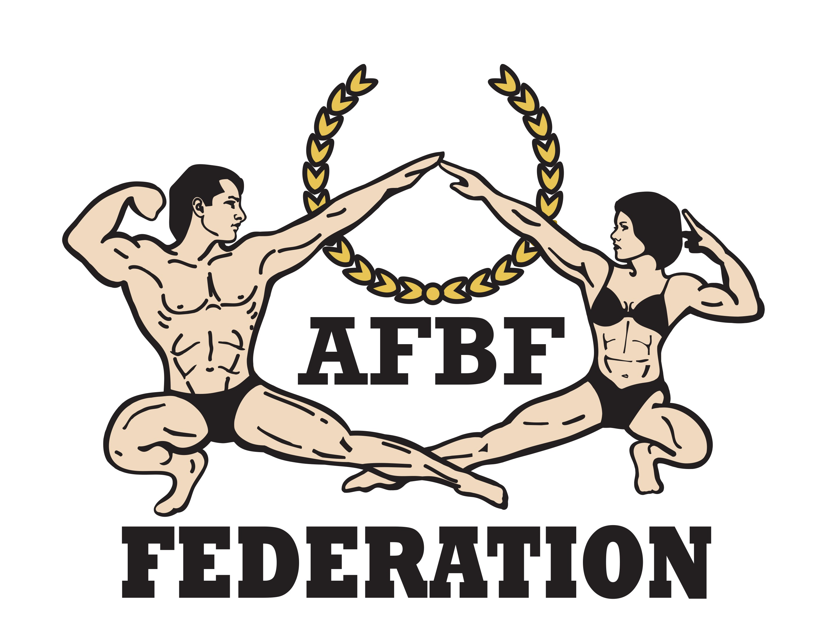


FINAL ENTRY FORM

Deadline date to send this Final Entry Form is Thursday, November 09th, 2023
2023 IFBB ARAB CHAMPIONSHIPS
November 17th to 20th, 2023 - ALEXANDRIA – EGYPT
ELITE PRO QUALIFIER
This Entry Form is to be completed and sent by National Federations, NOT by individual athletes
It is full responsibility and obligation of the National Federation to verify if each one of the athletes to be registered on this international event are NOT SUSPENDED or fulfilling any period of ineligibility due to Anti-Doping Rule Violation or any disciplinary case at national or international level.

COUNTRY |  | NATIONAL FEDERATION’S NAME |  |  |  | NF PRESIDENT’S NAME
FEDERATION’S CONTACT NO. (OFFICE OR CELL PHONE) |  |  |  | NATIONAL FEDERATION’S E-MAIL ADDRESS
 | If applicable: Responsible Delegate(s) name at this event |  |  |  | Cell phone |  | PASSPORT No.
1
2
Complete this Form in English Letters and leave it in the WORD format, so we can copy/paste the athletes’ names on our list. DO NOT change it to PDF format, please.
 | Competitor’s  1 Given NAME + 1 Family NAME |  | EXACT CATEGORY  (from the list of available categories below) |  |  |  | IFBB IC or  PASSPORT No.
1
2
3
4
5
6
7
8
9
10
11
12
13
14
15
16

IF YOU HAVE MORE ATHLETES, CONTINUE THIS TABLE, PLEASE.

This Final Entry Form will only be considered if it is sent by the National Federation of the athlete and directly to the Organizing Committee, IFBB Head Office in Madrid and IFBB Technical Committee (see e-mail addresses below). The final decision to allow an athlete to compete in this event rests with the IFBB.

Registration Fee for athletes is EUR €200 per person and will have to be paid in advance at IFBB webpage http://www.ifbb.com/competition-registration/ . Please add your name during the online payment and bring a copy of your payment confirmation to the registration. The online payment system will be switched off on Thursday, November 09th, 2023, 23:59 (midnight, Central European Time, UTC +1). If paying at the Registration on November 17th, 2023, the registration fee will be EUR €250.
Crossovers (additional categories) - additional fee of EUR €100 per each of additional categories will be charged.
CATEGORIES OPEN AT THE 2023 ARAB CHAMPIONSHIPS IN EGYPT:
Men Bodybuilding:  Up to & incl. 70 kg  Up to & incl. 80 kg  Up to & incl. 90 kg  Up to & incl. 100 kg  Over 100 kg  Junior Men Bodybuilding 16-20 yrs:  Up to & incl. 60 kg  Up to & incl. 75 kg  Over 75 kg  Junior Men Bodybuilding 21-23 yrs:  Up to & incl. 75 kg  Over 75 kg  Master Men Bodybuilding 40-49 yrs:  Up to & incl. 80 kg  Over 90 kg  Master Men Bodybuilding 50-59 yrs:  Up to & incl. 80 kg  Over 80 kg  Master Men Bodybuilding >60 yrs - OPEN | Men Classic Physique:*  Up to & incl. 173 cm  Up to & incl. 176 cm  Over 176 cm  Junior Men Classic Physique 16-23 yrs*:  Up to & incl. 176 cm  Over 176 cm  Men’s Physique:  Up to & incl. 173 cm  Up to & incl. 176 cm  Up to & incl. 179 cm  Over 179 cm  Junior Men’s Physique 16-20 yrs. - OPEN  Junior Men’s Physique 21-23 yrs:  Up to & incl. 176 cm  Over 176 cm  Muscular Men’s Physique:  Up to 176 cm  Over 176 cm
Note 1: A category will only be run if 3 or more athletes are registered. Otherwise, categories will be combined.
Note 2: *- Categories with weight / height limits

Please list your IFBB INTERNATIONAL JUDGES coming to this event:
 | NAME OF JUDGE(S) - (AS WRITTEN IN PASSPORT) | PASSPORT NUMBER
1
2
3

Please list your TEST- JUDGES names here:
 | NAME OF TEST- JUDGE(S) - (AS WRITTEN IN PASSPORT) | PASSPORT NUMBER
1
2
3

EXTRA DELEGATES AND SUPPORTERS
 | Extra Delegates or Supporters | If a Judge please  V |  | Extra Delegates or Supporters | If Judge please  V
1 |  |  | 8
2 |  |  | 9
3 |  |  | 10
4 |  |  | 11
5 |  |  | 12
6 |  |  | 13
7 |  |  | 14

Please send Entry Form no later than Thursday, November 09th, 2023 to:  Arab Bodybuilding & Fitness Federation President  Dr. Eng. Adel Fahim  E-mail: ifbbcairo@gmail.com  IFBB Technical Committee  Eng. Andrew Michalak  E-mail: amichalak5@gmail.com | Please send a copy to:  International Fitness & Bodybuilding Federation  Head Office:  E-mail: contact@ifbb.com

Date of issue:

Completed by (your name & position in the NF):

