International Fitness & Bodybuilding Federation
Dublin 39/I – Europolis – Las Rozas - Madrid – 28232 – Spain - Tel: (34) 5352819
E-mail: headquarters@ifbb.com Website: www.ifbb.com

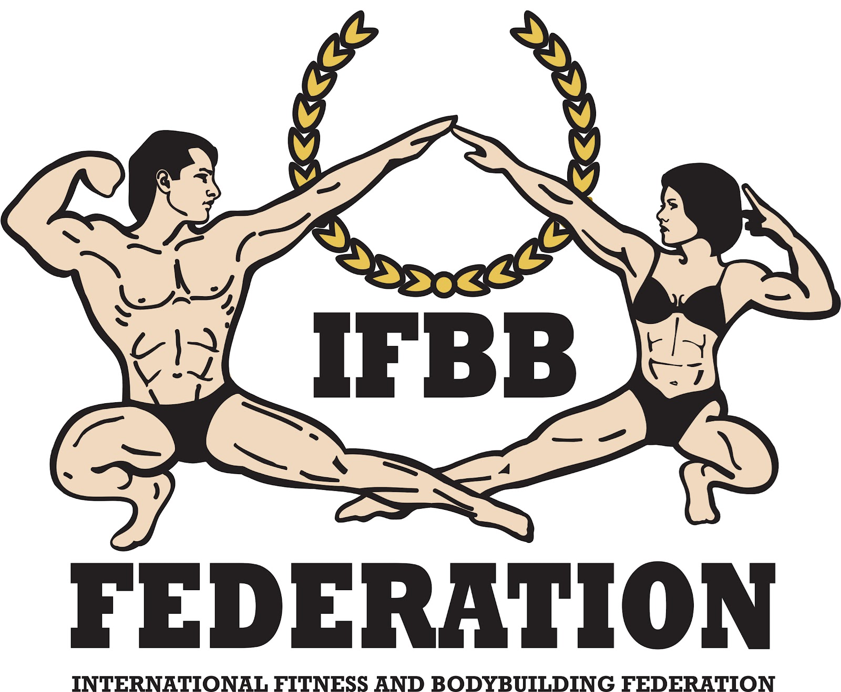

FINAL ENTRY FORM

Deadline date to send this Final Entry Form is Monday, August 26th, 2024
2024 IFBB EAST ASIAN CHAMPIONSHIPS
September 06th to 09th, 2024 - JEJU - REPUBLIC OF KOREA
Open to IFBB-affiliated National Federations from East Asian countries
ELITE PRO QUALIFIER
This Entry Form is to be completed and sent by National Federations, NOT by individual athletes
It is full responsibility and obligation of the National Federation to verify if each one of the athletes to be registered on this international event are NOT SUSPENDED or fulfilling any period of ineligibility due to Anti-Doping Rule Violation or any disciplinary case at national or international level.

COUNTRY |  | NATIONAL FEDERATION’S NAME |  |  |  | NF PRESIDENT’S NAME
FEDERATION’S CONTACT NO. (OFFICE OR CELL PHONE) |  |  |  | NATIONAL FEDERATION’S E-MAIL ADDRESS
 | If applicable: Responsible Delegate(s) name at this event |  |  |  | Cell phone |  | PASSPORT No.
1
2
Complete this Form in English Letters and leave it in the WORD format, so we can copy/paste the athletes’ names on our list. DO NOT change it to PDF format, please.
 | Competitor’s  1 Given NAME + 1 Family NAME |  | EXACT CATEGORY  (from the list of available categories below) |  |  |  | IFBB IC or  PASSPORT No.
1
2
3
4
5
6
7
8
9
10
11
12
13
14
15

IF YOU HAVE MORE ATHLETES, CONTINUE THIS TABLE, PLEASE.

This Final Entry Form will only be considered if it is sent by the National Federation of the athlete and directly to the Organizing Committee, IFBB Head Office in Madrid and IFBB Technical Committee (see e-mail addresses below). The final decision to allow an athlete to compete in this event rests with the IFBB.

Registration Fee for athletes is USD $330 per person (accommodation & meals included) and should be paid in advance by credit/debit card or PayPal at http://www.ifbb.com/competition-registration.
Please add your name during online payment and bring a copy of your payment confirmation to the registration. The online payment system will be switched off on August 27th, 2024, 23:59 (CEST > UTC + 2 in summer). Payments at arrival shall have an extra charge of USD $50.
Crossovers: an extra fee of USD $50 per each of the additional categories will be charged.

CATEGORIES OPEN AT THE 2024 EAST ASIAN CHAMPIONSHIPS IN JEJU:
Men Bodybuilding:  Up to & incl. 60 kg  Up to & incl. 65 kg  Up to & incl. 70 kg  Up to & incl. 75 kg  Up to & incl. 80 kg  Up to & incl. 85 kg  Up to & incl. 90 kg  Up to & incl. 100 kg  Over 100 kg  OVERALL (Elite Pro Cards for the top 3)  Junior Men Bodybuilding 16-23 yrs - OPEN  Master Men Bodybuilding:  40-49 yrs - OPEN  50 yrs & over – OPEN  OVERALL (Elite Pro Card for the winner)  Men Classic Bodybuilding:*  Up to & incl. 171 cm  Up to & incl. 175 cm  Up to & incl. 180 cm  Over 180 cm  Junior Men Classic Bodybuilding 16-23 yrs* – OPEN  Master Men Classic Bodybuilding*:  40-49 yrs - OPEN  50 yrs & over - OPEN  Men Classic Physique:*  Up to & incl. 175 cm  Over 175 cm  OVERALL (Elite Pro Cards for the winner)  Master Men Classic Physique:*  40-49 yrs - OPEN  50 yrs & over - OPEN  Men’s Physique:  Up to & incl. 173 cm  Up to & incl. 176 cm  Up to & incl. 179 cm  Over 179 cm  OVERALL (Elite Pro Cards for the top 2)  Junior Men’s Physique 15-23 yrs - OPEN  Muscular Men’s Physique:  Up to & incl. 175 cm  Over 175 cm  Men’s Fit-Model – OPEN | Women’s Bodyfitness:  Up to & incl. 163 cm  Over 163 cm  OVERALL (Elite Pro Card for the winner)  Junior Women’s Bodyfitness 16-23 yrs – OPEN  Master Women’s Bodyfitness:  35-39 yrs - OPEN  40 yrs & over – OPEN  OVERALL (Elite Pro Card for the winner)  Women’s Bikini:  Up to & incl. 162 cm  Up to & incl. 166 cm  Over 166 cm  OVERALL (Elite Pro Cards for the top 2)  Junior Women’s Bikini 16-23 yrs – OPEN  Master Women’s Bikini:  35-39 yrs - OPEN  40 yrs & over – OPEN  OVERALL (Elite Pro Card for the winner)  Women’s Wellness:  Up to & incl. 163 cm  Over 163 cm  OVERALL (Elite Pro Card for the winner)  Junior Women’s Wellness 16-23 yrs – OPEN  Master Women’s Wellness:  35-39 yrs - OPEN  40 yrs & over - OPEN  Women’s Fit-Model:  Up to & incl. 164 cm  Over 164 cm  Junior Women’s Fit-Model 16-23 yrs – OPEN  Master Women’s Fit-Model >35 yrs – OPEN  Women’s Physique:  Up to & incl. 163 cm  Over 163 cm  OVERALL (Elite Pro Cards for the winner)  Master Women’s Physique >35 yrs - OPEN
Note 1: A category will only be run if 5 or more athletes are registered. Otherwise, categories will be combined.
Note 2: *- Categories with weight / height limits
Possible crossovers: Classic Bodybuilding – Classic Physique – Bodybuilding. Women’s Bikini – Fit-Model; Women’s Wellness – Fit- Model; Also junior and masters in senior classes.

Please list your IFBB INTERNATIONAL JUDGES coming to this event:
 | NAME OF JUDGE(S) - (AS WRITTEN IN PASSPORT) | PASSPORT NUMBER
1
2
3

Please list your TEST- JUDGES names here:
 | NAME OF TEST- JUDGE(S) - (AS WRITTEN IN PASSPORT) | PASSPORT NUMBER
1
2
3

 | Extra Delegates or Supporters | If a Judge please  V |  | Extra Delegates or Supporters | If Judge please  V
1 |  |  | 6
2 |  |  | 7
3 |  |  | 8
4 |  |  | 9
5 |  |  | 10
EXTRA DELEGATES AND SUPPORTERS
Please send Entry Form no later than Monday, August 26th, 2024 to:  Jeju Bodybuilding & Fitness Federation  E-mail: kbbf1987@naver.com  IFBB Technical Committee  Eng. Andrew Michalak  E-mail: amichalak5@gmail.com | Please send a copy to:  International Fitness & Bodybuilding Federation  Head Office:  E-mail: contact@ifbb.com

Date of issue:

Completed by (your name & position in the NF):

