International Fitness & Bodybuilding Federation
Dublin 39/I – Europolis – Las Rozas - Madrid – 28232 – Spain - Tel: (34) 5352819 Fax: (34) 5351518
E-mail: headquarters@ifbb.com Website: www.ifbb.com

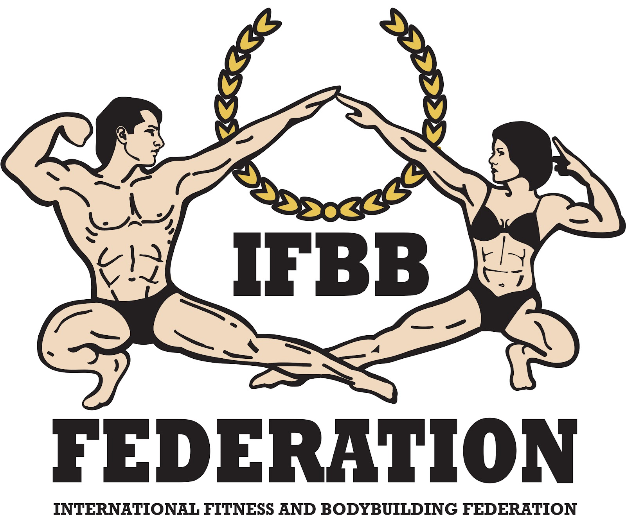

FINAL ENTRY FORM

Deadline date to send the Entry Form is Saturday, August 03rd, 2024
IFBB MR. & MS. AMERICA
August 09th – 12th, 2024, QUITO – ECUADOR
OPEN TO ALL IFBB COUNTRIES, IFBB WORLD RANKING EVENT, ELITE PRO QUALIFIER
This Entry Form is to be completed and sent by National Federations, NOT by individual athletes
It is full responsibility and obligation of the National Federation to verify if each one of the athletes to be registered on this international event are NOT SUSPENDED or fulfilling any period of ineligibility due to Anti-Doping Rule Violation or any disciplinary case at national or international level.

COUNTRY |  | NATIONAL FEDERATION’S NAME |  |  |  | NF PRESIDENT’S NAME
CONTACT No (NATIONAL FEDERATION OFFICE OR CELL PHONE) |  |  |  | NF FEDERATION’S E-MAIL ADDRESS
 | If applicable: Responsible Delegate(s) name at this event |  |  |  | Cell phone |  |  | PASSPORT NR
1
2
Complete this Form ENGLISH LETTERS and leave it in the WORD format, so we can copy/paste the athletes’ names on our list. DO NOT change it to PDF format, please.
 | Competitor’s  1 Given NAME + 1 Family NAME |  | EXACT CATEGORY  (According to the list of categories below) |  |  |  | IFBB IC or  PASSPORT NO.
1
2
3
4
5
6
7
8
9
10
11
12
13
IF YOU HAVE MORE ATHLETES, CONTINUE THIS TABLE, PLEASE.

ALL THE COSTS FOR TRAVELLING, HOTEL ACCOMMODATIONS AND MEALS (AND TRANSPORT FROM AND TO THE AIRPORT) MUST BE COVERED BY NATIONAL FEDERATIONS. HOTEL RESERVATION MUST BE DONE BY DIRECT COMMUNICATION BETWEEN THE NATIONAL FEDERATION AND THE HOTEL. CHECK WITH YOUR NATIONAL FEDERATION FOR MORE INFORMATION.

IMPORTANT NOTES:
The Organizer of the event in QUITO, ECUADOR, will not accept any direct registration from athletes.
This Entry Form will only be considered if sent by the National Federation of the athlete and directly to the CSFF Head Office, IFBB Head Office and IFBB Technical Committee (see email addresses below). The final decision to allow an athlete to compete in this event rests with the IFBB.
Registration fee is USD $120 per athlete and must be paid at the Registration in Quito (by cash). Athletes wishing to participate in more than one category must pay the additional fee of USD $60 per each of the additional categories. IFBB International Card or its renewal for 2024 is USD $50 /EUR €40.
CATEGORIES OPEN AT THE COMPETITION
MEN’S BODYBUILDING
UP TO & INCLUDING 70 kg
UP TO & INCLUDING 75 kg
UP TO & INCLUDING 80 kg
UP TO & INCLUDING 85 kg
UP TO & INCLUDING 90 kg
OVER 90 kg

JUNIOR MEN’S BODYBUILDING 16-23 YEARS – OPEN

MASTERS MEN’S BODYBUILDING:
40-49 YEARS – OPEN
50-59 YEARS – OPEN
60 YEARS & OVER - OPEN

MEN’S GAMES CLASSIC BODYBUILDING – OPEN

MEN’S CLASSIC BODYBUILDING
UP TO & INCLUDING 171 cm
OVER 171 cm
MEN’S CLASSIC PHYSIQUE
UP TO & INCLUDING 171 cm
OVER 171 cm

MEN’S PHYSIQUE
UP TO & INCLUDING 167 cm
UP TO & INCLUDING 170 cm
UP TO & INCLUDING 173 cm
OVER 173 cm
JUNIOR MEN’S PHYSIQUE 15-23 YEARS – OPEN
MASTER MEN’S PHYSIQUE >40 YEARS – OPEN

MUSCULAR MEN’S PHYSIQUE – OPEN

CHALLENGER MEN’S BODYBUILDING
UP TO & INCLUDING 70 kg
UP TO & INCLUDING 80 kg
OVER 80 kg

MASTER CHALLENGER BODYBUILDING >40 YRS - OPEN

CHALLENGER CLASSIC BODYBUILDING - OPEN

CHALLENGER CLASSIC PHYSIQUE - OPEN

CHALLENGER MEN’S PHYSIQUE
UP TO & INCLUDING 170 cm
OVER 170 cm
CHALLENGER MUSCULAR MEN’S PHYSIQUE - OPEN

WOMEN’S ARTISTIC FITNESS – OPEN

WOMEN’S BODYFITNESS – OPEN

WOMEN’S BIKINI
UP TO & INCLUDING 160 cm
UP TO & INCLUDING 164 cm
OVER 164 cm
JUNIOR WOMEN’S BIKINI 16-23 YEARS – OPEN

MASTER WOMEN’S BIKINI >35 YEARS – OPEN

WOMEN’S WELLNESS
UP TO & INCLUDING 158 cm
UP TO & INCLUDING 160 cm
OVER 160 cm
JUNIOR WOMEN’S WELLNESS 16-23 YEARS – OPEN
MASTER WOMEN’S WELLNESS >35 YEARS – OPEN
WOMEN’S PHYSIQUE - OPEN

WOMEN’S FIT- MODEL – OPEN

FIT- PAIRS – OPEN

CHILDREN FITNESS – GIRLS:
UP TO 9 YRS OLD
OVER 9 YRS OLD

CHALLENGER WOMEN’S BODYFITNESS – OPEN

CHALLENGER WOMEN’S BIKINI
UP TO & INCLUDING 162 cm
OVER 162 cm
CHALLENGER WOMEN’S WELLNESS
UP TO & INCLUDING 163 cm
OVER 163 cm

Challengers: Athletes who haven’t competed internationally or who were not in the top 10 at any of the international events.
Permitted crossovers:
Juniors and masters in senior classes;
Men’s Games Classic Bodybuilding - Classic Bodybuilding - Classic Physique – Bodybuilding;
Women’s Wellness – Women’s Fit-Model;
Women’s Artistic Fitness – Women’s Bikini – Women’s Fit-Model.

Note: A category will only be run if 3 or more athletes are registered. Otherwise, categories will be combined, whenever possible.
Please send Entry Form no later than August 03rd, 2024 to:  South American Confederation Head Office:  csff.ifbb@gmail.com  IFBB Technical Committee:  Eng. Andrew Michalak  E-mail: amichalak5@gmail.com | Please send a copy to:  International Federation of Bodybuilding and Fitness  Head Office:  Ms. Daria  E-mail: contact@ifbb.com

NOMINATION OF INTERNATIONAL JUDGES COMING TO THIS EVENT:
 | NAME (AS WRITTEN IN PASSPORT) | PASSPORT NUMBER
1
2
3

PLEASE LIST YOUR TEST- JUDGES COMING TO THIS EVENT:
 | NAME (AS WRITTEN IN PASSPORT) | PASSPORT NUMBER
1
2
3

Please list your EXTRA DELEGATES AND SUPPORTERS here:
 | Extra Delegates or Supporters | If a Judge please  V |  | Extra Delegates or Supporters | If Judge please  V
1 |  |  | 6
2 |  |  | 7
3 |  |  | 8
4 |  |  | 9
5 |  |  | 10

Date of issue:

Completed by (your name & position in the NF):

