International Fitness & Bodybuilding Federation
Dublin 39/I – Europolis – Las Rozas - Madrid – 28232 – Spain - Tel: (34) 5352819
E-mail: headquarters@ifbb.com Website: www.ifbb.com

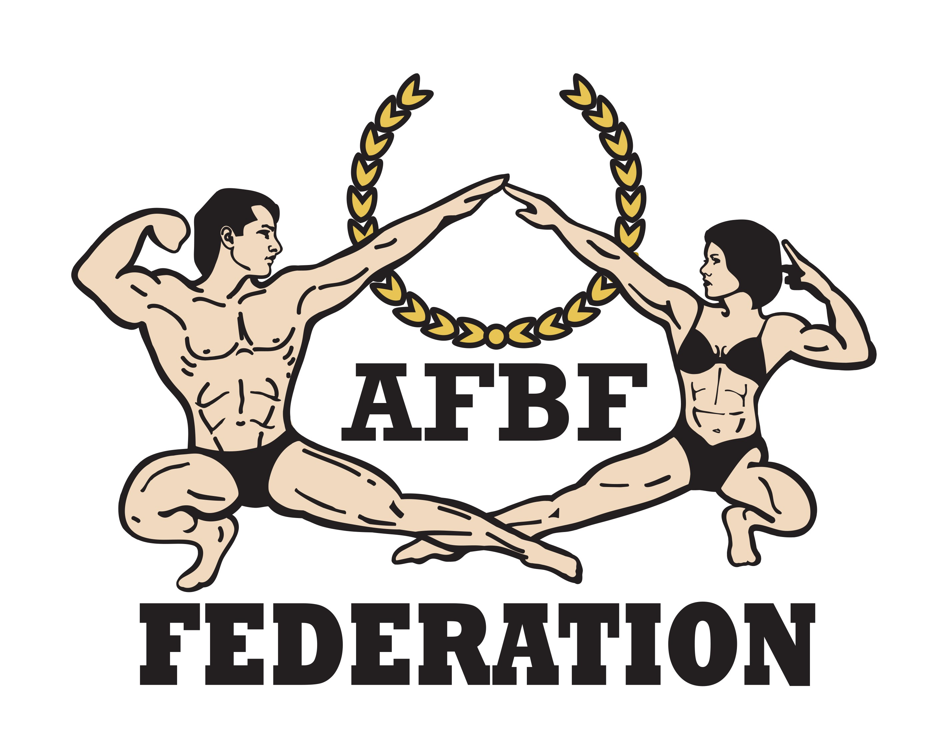


FINAL ENTRY FORM

Deadline date to send this Final Entry Form is Friday, August 09th, 2024
2024 IFBB WEST ASIAN CHAMPIONSHIPS
August 15th to 18th, 2024 - MUSCAT - OMAN
ELITE PRO QUALIFIER
This Entry Form is to be completed and sent by National Federations, NOT by individual athletes
It is full responsibility and obligation of the National Federation to verify if each one of the athletes to be registered on this international event are NOT SUSPENDED or fulfilling any period of ineligibility due to Anti-Doping Rule Violation or any disciplinary case at national or international level.

COUNTRY |  | NATIONAL FEDERATION’S NAME |  |  |  | NF PRESIDENT’S NAME
FEDERATION’S CONTACT NO. (OFFICE OR CELL PHONE) |  |  |  | NATIONAL FEDERATION’S E-MAIL ADDRESS
 | If applicable: Responsible Delegate(s) name at this event |  |  |  | Cell phone |  | PASSPORT No.
1
2
Complete this Form in English Letters and leave it in the WORD format, so we can copy/paste the athletes’ names on our list. DO NOT change it to PDF format, please.
 | Competitor’s  1 Given NAME + 1 Family NAME |  | EXACT CATEGORY  (from the list of available categories below) |  |  |  | IFBB IC or  PASSPORT No.
1
2
3
4
5
6
7
8
9
10
11
12
13
14
15
16

IF YOU HAVE MORE ATHLETES, CONTINUE THIS TABLE, PLEASE.

This Final Entry Form will only be considered if it is sent by the National Federation of the athlete and directly to the Organizing Committee, IFBB Head Office in Madrid and IFBB Technical Committee (see e-mail addresses below). The final decision to allow an athlete to compete in this event rests with the IFBB.

Registration Fee for athletes is USD $200 per person and should be paid in cash at the Registration in Oman.
Additionally, each athlete will have to pay USD $70 for tanning services.

Crossovers: an extra fee of USD $100 per each of the additional categories will be charged.
Possible crossovers: Classic Bodybuilding – Classic Physique – Bodybuilding. Also junior and masters in senior classes.

CATEGORIES OPEN AT THE 2024 WEST ASIAN CHAMPIONSHIPS IN OMAN:
Men Bodybuilding:  Up to & incl. 65 kg  Up to & incl. 70 kg  Up to & incl. 75 kg  Up to & incl. 80 kg  Up to & incl. 85 kg  Up to & incl. 90 kg  Up to & incl. 95 kg  Over 95 kg  OVERALL (Elite Pro Cards for the top 3)  Junior Men Bodybuilding 16-23 yrs:  Up to & incl. 75 kg  Over 75 kg  OVERALL  Master Men Bodybuilding >40 yrs:  Up to & incl. 80 kg  Over 80 kg  OVERALL  Men Classic Bodybuilding:*  Up to & incl. 171 cm  Up to & incl. 175 cm  Up to & incl. 180 cm  Over 180 cm  OVERALL (Elite Pro Cards for the top 2)  Junior Men Classic Bodybuilding 16-23 yrs:*  Up to & incl. 175 cm  Over 175 cm  OVERALL  Master Men Classic Bodybuilding >40 yrs* - OPEN | Men’s Physique:  Up to & incl. 170 cm  Up to & incl. 173 cm  Up to & incl. 176 cm  Up to & incl. 179 cm  Over 179 cm  OVERALL (Elite Pro Cards for the top 2)  Junior Men’s Physique 15-23 years:  Up to & incl. 176 cm  Over 176 cm  OVERALL  Master Men’s Physique >40 yrs - OPEN  Muscular Men’s Physique:  Up to 176 cm  Over 169 cm  OVERALL (Elite Pro Card for the winner)  Men Classic Physique:*  Up to & incl. 171 cm  Up to & incl. 175 cm  Up to & incl. 180 cm  Over 180 cm  OVERALL (Elite Pro Cards for the top 2)  Junior Men Classic Physique 16-23 yrs:*  Up to & incl. 175 cm  Over 175 cm  OVERALL  Master Men Classic Physique >40 yrs* - OPEN
Note 1: A category will only be run if 5 or more athletes are registered. Otherwise, categories will be combined.
Note 2: *- Categories with weight / height limits

Please list your IFBB INTERNATIONAL JUDGES coming to this event:
 | NAME OF JUDGE(S) - (AS WRITTEN IN PASSPORT) | PASSPORT NUMBER
1
2
3

Please list your TEST- JUDGES names here:
 | NAME OF TEST- JUDGE(S) - (AS WRITTEN IN PASSPORT) | PASSPORT NUMBER
1
2

EXTRA DELEGATES AND SUPPORTERS
 | Extra Delegates or Supporters | If a Judge please  V |  | Extra Delegates or Supporters | If Judge please  V
1 |  |  | 8
2 |  |  | 9
3 |  |  | 10
4 |  |  | 11
5 |  |  | 12
6 |  |  | 13
7 |  |  | 14

Please send Entry Form no later than Friday, August 09th, 2024 to:  Omani Bodybuilding Federation  E-mail: omanbodybuilding@mcsy.gov.om  Tel: +968 99344612  IFBB Technical Committee  Eng. Andrew Michalak  E-mail: amichalak5@gmail.com | Please send a copy to:  West Asian Federation President  Mr. Manar Haikal  Tel: +963 991070000  E-mail: westasiabodybuildingfederation@gmail.com  International Fitness & Bodybuilding Federation  Head Office:  E-mail: contact@ifbb.com

Date of issue:

Completed by (your name & position in the NF):

