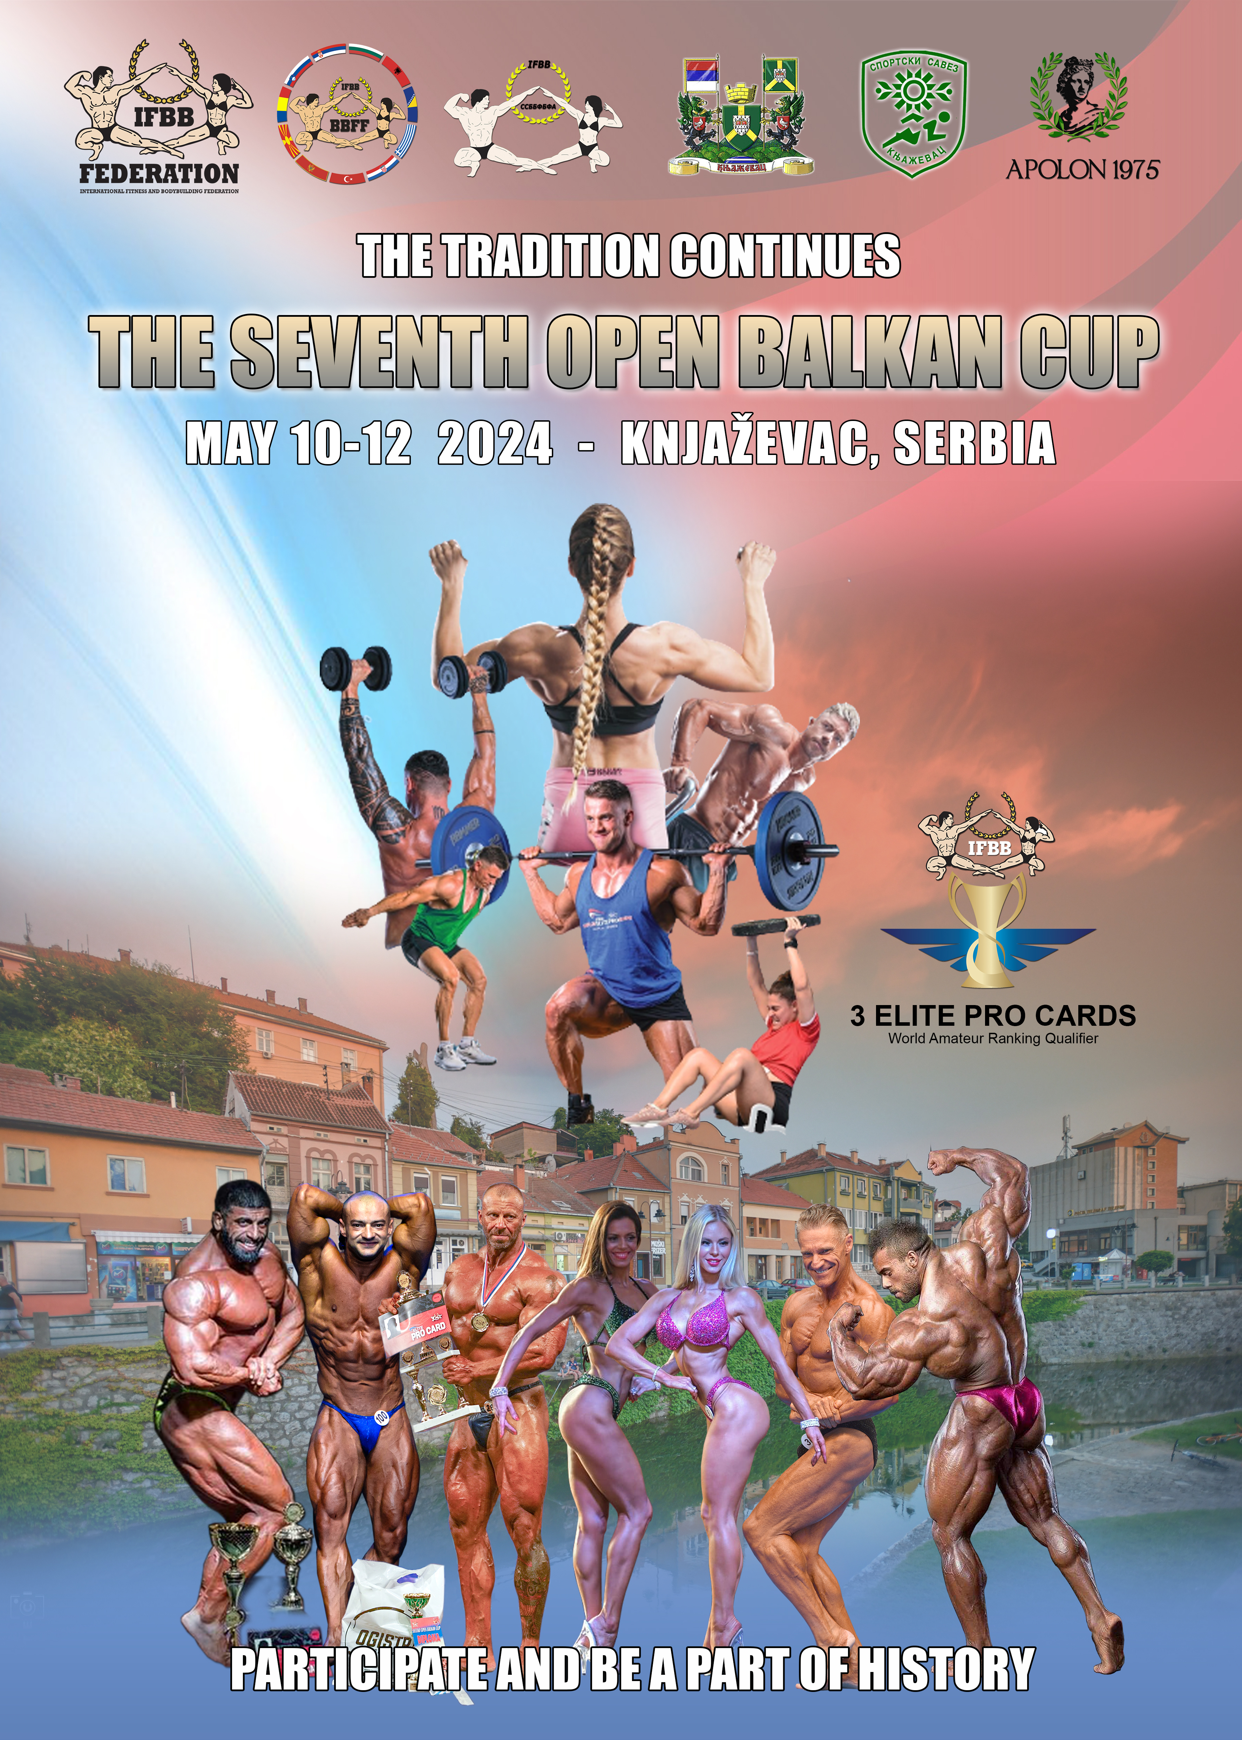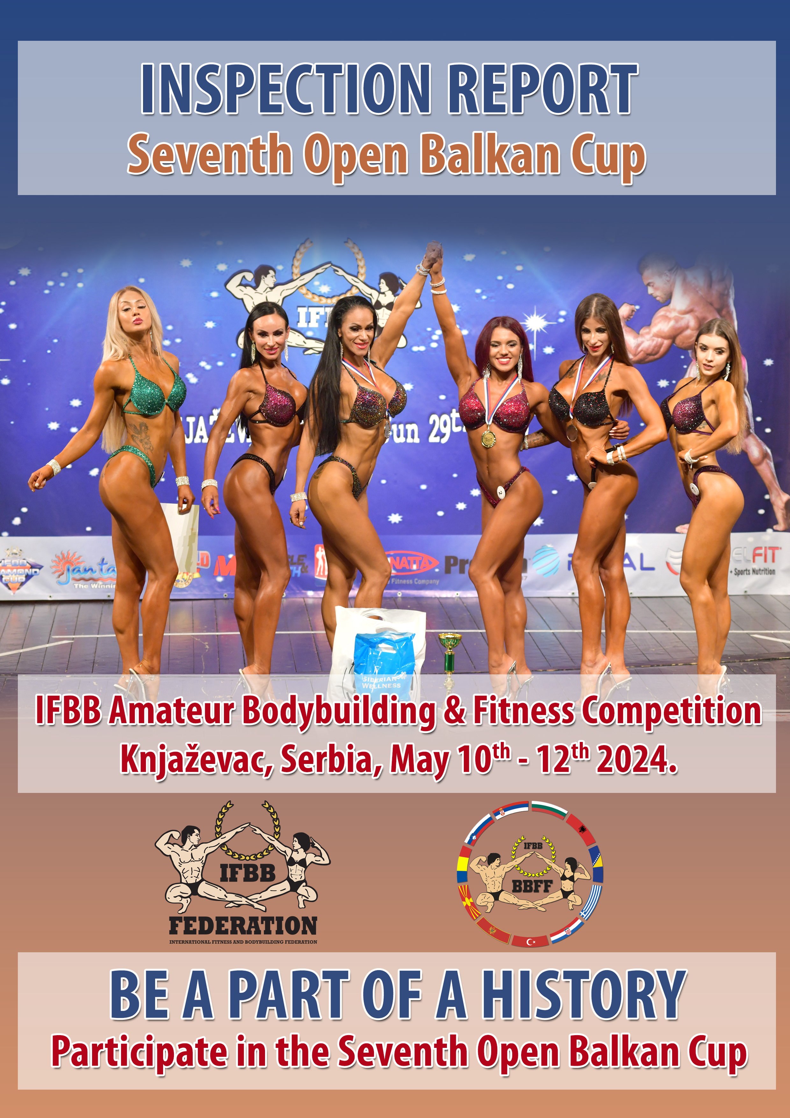

WELCOME: The President of the Organizing Committee Mr. Milan Djokić, Mayor of Knjaževac, invites all Balkan National Federations – members of the IFBB – to participate in the

IFBB SEVENTH OPEN BALKAN CUP AND THIRD KID’S GOLD GRAND PRIX


IFBB Amateur Bodybuilding & Fitness Competition
that will take place in Knjaževac, Serbia on May 10th – 12th, 2024.

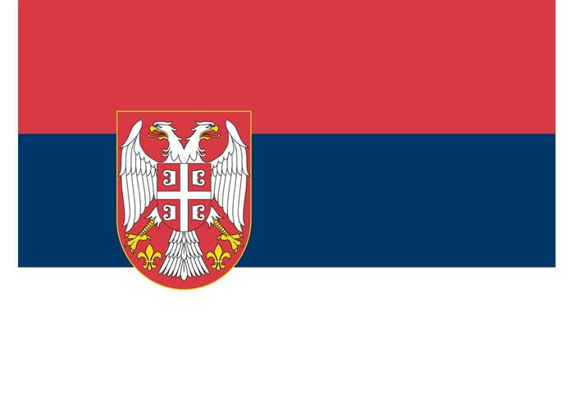
Serbia has connected West with East for centuries – a land in which civilizations, cultures, faiths, climates and landscapes meet and mingle. It is located in the center of the Balkan Peninsula, in southeast- ern Europe. The northern portion belongs to central Europe, but in terms of geography and climate it is also partly a Mediterranean country. Serbia is landlocked but as a Danube country it is connected to distant seas
and oceans. Serbia is a crossroads of Europe and a geopolitically important territory. The international roads and railway lines, which run through the country’s river valleys, form the shortest link between Western Europe and the Middle East.
From the agricultural regions of the Pannonia Plain in the north, across the fertile river valleys and orchard-covered hills of Šumadija, the landscape of Serbia continues southward, gradually giving way to mountains rich in canyons, gorges and caves, as well preserved forests. Serbia’s beautiful mountains, nation- al parks, rivers and lakes are the perfect location for an active outdoor holiday – from hunting and fishing to extreme sports.
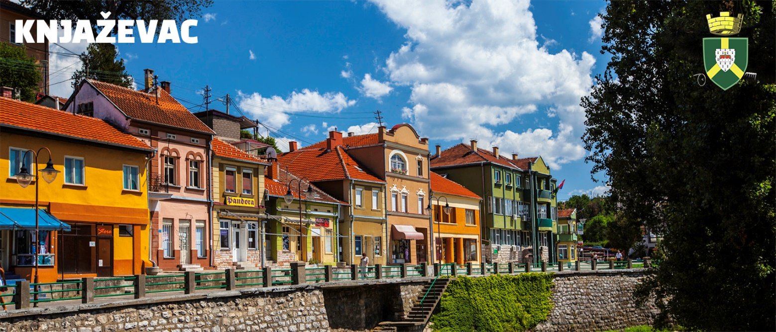
Many times during its rich, centuries-long history, Serbia has been at the center of Europe’s and the world’s attention, out of all proportion to its modest size, economic might and number of inhabitants.
Knjaževac area is settled during prehistoric times, the evidenced of this are settlements of Baranica, Škodrino polje, Dubrava, etc., horseman cave drawing in Gabrovnica and other archaeological findings. The ancient chronicler Pliny (II century AD) records this territory as a part of the Roman province of Moesia in which live Mezi people, Thracians, Dardanians, Tribals, Timahs, who had been formed, in symbiosis with the Slavic tribes, the local indigenous population of Timočani, called Putuk- lije.

Many lessons on bravery, patriotism and the struggle for freedom can be learned wherever you turn in Serbia, as you pass through its cities and regions. The cultural and historical heritage of Serbia begins with pre- historic archaeological sites and its legacy from classical antiquity. Perhaps its greatest riches, though, are in the many mediaeval Serbian churches and monasteries, some of which are included on the UNESCO World Heritage list. All year round, numerous cultural, entertainments, traditional and sporting events are held in Serbia, demonstrating the creative power and spiritual vitality of this country. Today, Serbia is a modern, democratic European country, on the path to membership of the European Union, which a diverse range of visitors – from young backpackers to participants in congresses and fairs – visit every day.

Roman fort Timacum Minus, near village of Ravna, with excavated walls, parts of the civil settle- ment, the rich necropolis, explains the history of the period of Knjaževac area until the Middle Ages. In the town were found the remains of the other famous, Late Roman town, Timacum maius.

In the Roman road map from the IV century Knježevac was written under the name of Timac Maio- ri, a settlement that is built on the foundations of the fortress Veliki Timok on the Zdanije hill (the present church, “St. George”).
From the period of medieval century are towns Ravna and Koželj, Church of the Virgin in Gornja Kamenica and Holy Trinity Monastery in Donja Kamenica, which were built in the XV century, and the first track of the name Gurgusovac. In some older literature this place were called Kolumbija, it comes from the Latin word columba, meaning pigeon and a true translation is Golubac. This term has no archaeological or
written confirmation. In the same time with this name was used, for a long time, name Gurgusovac.This name is mentioned in the Turkish census from 1455. Country legend says that this is the name given by Gri- vas pigeons.
The Turks conquered this area 1396 and annexed it to Vidinski pašaluk. From the time of the Turk- ish rule there is little information from this area. Records from the VII century precisely recorded Gurgusovac as a military fort with palisades and cannon, with 46 Turkish and 120 Christian homes.
First Serbian Rebellion came in Knjaževac area at 1807 when Hajduk Veljko attacked Gurgusovac, but he could not conquer it until the Serbian-Russian victory in Malajnica. After the Serbian defeat in Čegar, Turks again conquered Gurgusovac. With the capitulation of Serbia 1813, capitulated Gurgusovac, which was again, connected Vidinski pašaluk, until the liberation from the Turks and its association to Serbia
1833. The town inherited Gurgusovac Tower, the prison for political prisoners, known as “The Serbian Bas- tille”. The tower was burned by order of Prince Miloš Obrenović, so in his honor, the citizens changed the name of town to Knjaževac in 1859.

Difficult economic situation after the war and new taxes for railroad Belgrade - Niš and for military weapons, as well as immediate political situation in the country, led to a revolt Timočka buna in 1883.
The immediate cause of the revolt was collection of weapons from the national army and the rebellion swept Knjaževac and Knjaževac discrict in October 1883. and one of the initiators of the rebellion was Aca Stanojević from Knjaževac.

People from Knjaževac were good fighters through all the wars that affected this region, as the Serbo-Bulgarian War, Balkans, and World War I. During the withdrawal of Serbian military in 1915 they were particularly emphasized in the battles for the defense of Belgrade. XIV regiment within the Second Army in breakthrough of Salonika Front in 1918 in crossed the Drina river as the vanguard and it first came to Sarajevo, and reached the Adriatic Sea. After the war flag of the XIV regiment was awarded by Karadjordje Star.

The period between the two wars will be remembered by people who live in Knjaževac in the sign of the development of the municipality, opening of different craft shops and workshops, as well as the industry’s first capacity: tanneries, brick wine cellar, so that Knjaževac gets all the elements of the urban environment.

World War II in Knjaževac started with demonstrations against the signing of the pact of associa- tion of Yugoslavia with the Tripartite Pact on March 25/27, 1941 and the occupation of the 11th April 1941 by Germany and the occupation of Budžak by Bulgaria. After a long battle with the Bulgarians and Germans, Knjaževac was finally released on October 10th, 1944.

The rapid development started in 1960 when they started clothing industry “Branka Dinić”, shoe factory “Leda”, tractors and machinery industry IMT, Timok furniture industry “Tina”, a wine cellar became the “Džervin”.

From all of this we can say that the period since 1970.until 1985 were the most important in current development of Knjaževac in all elements of economic and social development. During this period, some buildings which are the symbols of Knjaževac were erected, namely: the Cultural Center, Health Center, Kindergarten, and kindergarten network, several apartment blocks, and, as for the cultural community of Knjaževac is best known one national festival, the Festival of Youth Culture of Serbia, which was established 1962 and continues until today.

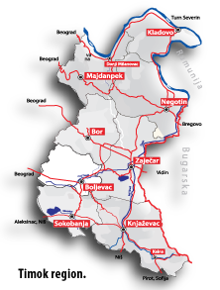
GEOGRAPHICAL DATA

Knjaževac municipality is located in eastern Serbia, near the border with the Republic of Bulgaria and it is part of the Timok region. The municipality covers an area of 1202 km² and it is the fourth largest in the Re-
public of Serbia. A significant part of Knjaževac is part
of the hilly-mountainous region.

The highest point on the municipal territory is Midžor on Stara Planina mountain (2169 m a.s.l.), which is the highest peak in the Republic of Serbia. The lowest
point is 176 m above sea level and it is located in Kn- jaževac valley. The municipality includes 86 settlements, 85 villages and one town. The town itself is situated on the composition of Trgoviški Timok and Svrljiški Timok which make up Beli Timok, which runs to Zajecar and together with the Crni Timok makes theTimok. The Timok Region is named by that river.
In Knjaževac live 37,172 inhabitants, 19,705 in the town (data from the last census in 2002). The average population density is 31 inhabitants per km², which is classified as a sparsely populated municipality.
Knjaževac is connected with other cities and towns by road and rail traffic. Distance from other cities: Belgrade 280 km, Zaječar 40 km, Niš 60 km, Prahovo - Danube 110 km, Sokobanja 41 km, Pirot 64 km, Sofia 147 km.

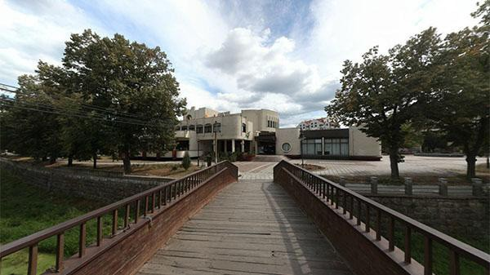


Culture Center Knjaževac

TOURISM

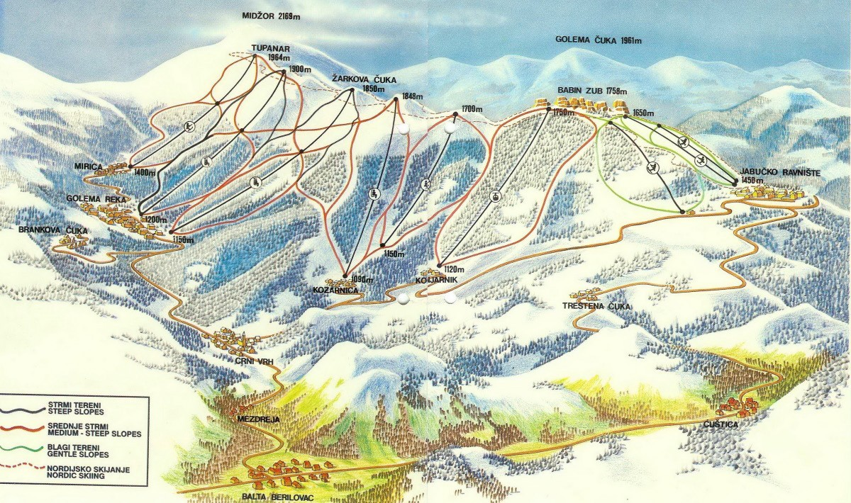
Knjaževac, with its ski resort Babin Zub offers opportunities for tourism and sports events. Its picnic areas are set in areas of natural beauty (like Banjica, Baranica etc.), places for rest and recreation. The 14th-century Church of the Holy Mother of God lies in the nearby village of Donja Kamenica. In 2014 Knjaževac was chosen as the outstanding destination in Europe. (Project EDEN Network)
Ski resort Babin Zub

Located near the town of Knjaževac, Stara Planina is the largest mountain in eastern Serbia. This high mountain range of fascinating beauty and unspoiled nature is a natural border with Bulgaria. A one of the most beautiful mountains in our country, Stara Planina has vast potential for the development of tourism. This mountain is a natural resource of extraordinary importance as falls into first category natural resources.
This belle is covered in snow for almost five months a year. Being between 1,100 and 1,900m high, it has
excellent potential for the construction of long alpine skiing runs.
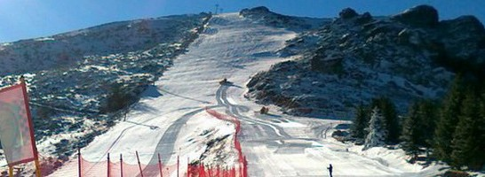
Babin Zub, situated at an elevation of 1,758m, is one of the most beautiful landscapes of Stara Planina. The striking rocks of Babin Zub end to the southeast of Midzor (2,169m high), the highest peak of Stara Planina and Serbia. Babin Zub is a protected natural reserve.

-

ACCOMMODATION:
There are three hotels available for accommodation, HOTEL “TIMOK”, “MALI PREDAH” and “BARKA”, and they are located near the venue.
The cost of accommodation for athletes and delegates in double room is included in the registration fee of EUR €150, including 2-night hotel accommodations (double room), with breakfast, lunch packet at venue site and banquet on May11th and breakfast on May 12th) and tickets for the Prejudging, Finals and Farewell Banquet.
The organizer provided a special package for supporters: EUR €100 - including 2-night hotel accommodations (double room), with breakfast, lunch packet at venue site and banquet on May11th and breakfast on May 12th) and tickets for the Prejudging, Finals and Farewell Banquet.
For reservation please contact the organizer at apolon1975knjazevac@gmail.com

PLEASE NOTE: Reservation, booking and all costs for the hotel accommodation, traveling, trans- port from and to the airport and meals are the responsibilities of the national federations or individual athletes. Check with your National Federation for more information.

HOTELS:

GARNI HOTEL “MALI PREDAH”

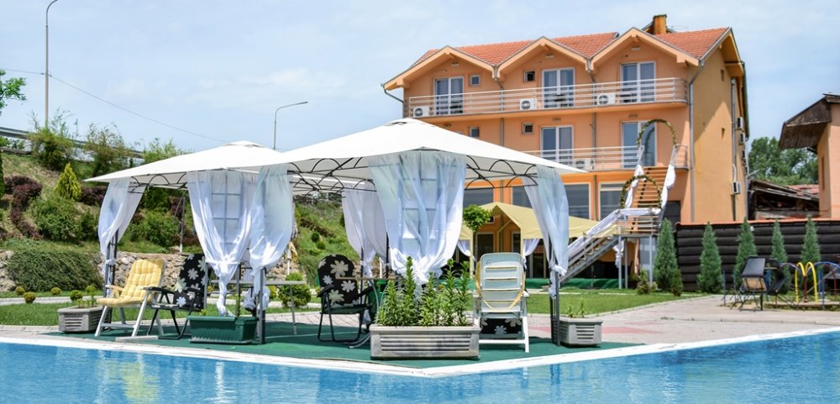
Situated in Knjaževac, this hotel is 1.1 km far from the Culture Center where BC will be held. “Mali Predah” offers a breakfast, lunch and dinner to guests, depending on guest’s needs. The Guest house Mali Predah also features a restaurant and a bar. Guestrooms also feature cable TV, Wi-Fi, internet connection, telephone line. 2-bed rooms, 3-bed rooms, 4-bed rooms and apartments are available. Parking is also available for guest’s cars.

Restaurant „Mali Predah“exists and works from 1983. For almost a quarter of century of existing, from modest restaurant at the beginning, it grew up into the object which can offer top services in food and accommodations today. This restaurant of modern look has two restaurants ball-rooms. The smaller one has capacity for one hundred seats and the bigger one able for five hundred seats.

Beside excellent accommodation there is a fulfill menu, which offers different kind of food and drinks, and cooks of „Mali Predah“ are famous in their cooking skills. Beside traditional meals of Serbian kitchen, in this restaurant you can also try local specialties and of course, all of that goes with top services and nice and kind staff of „Mali Predah“.

HOTEL TIMOK

Hotel „Timok“ is located in the city park. It has a restraint and a tavern with a big terrace that can ocuppy 200 seats. Every room has a TV, inter- net – WiFi, bathroom. Hotel offers double rooms,
double rooms with an extra bed and apartments. Hotel is especially good for accommodation of sports team considering that it’s only 100 meters away from the Culture Center of Knjaževac.

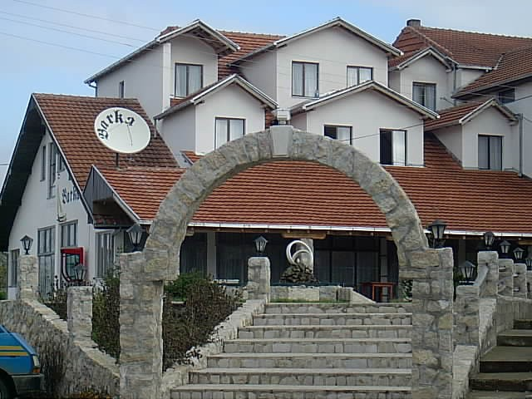
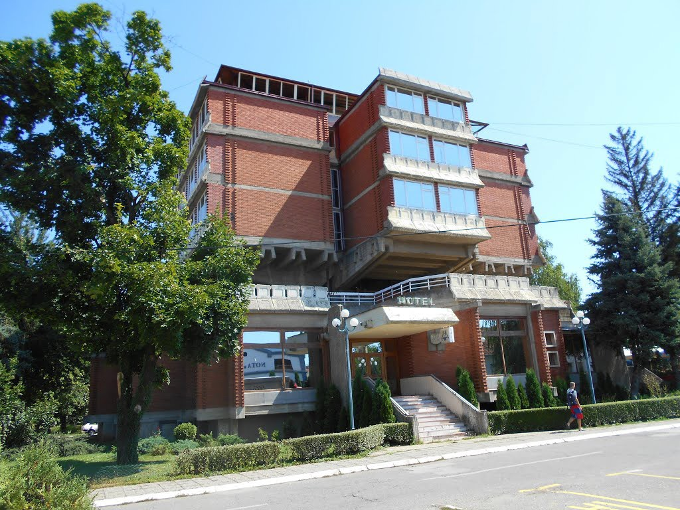

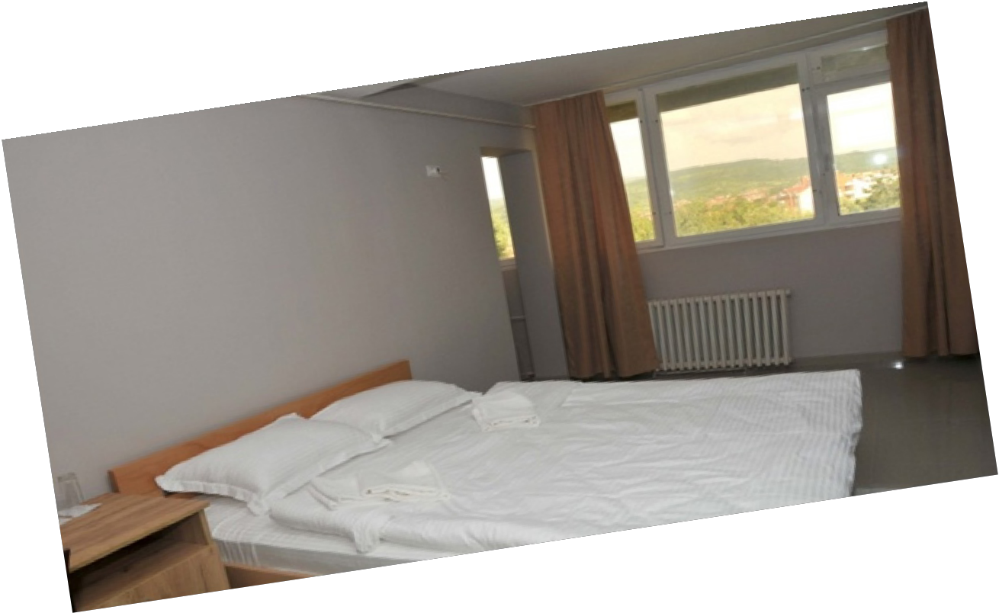
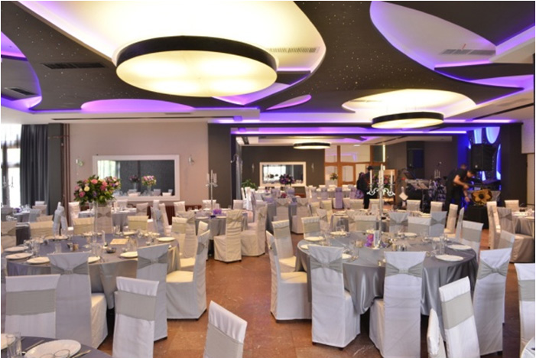



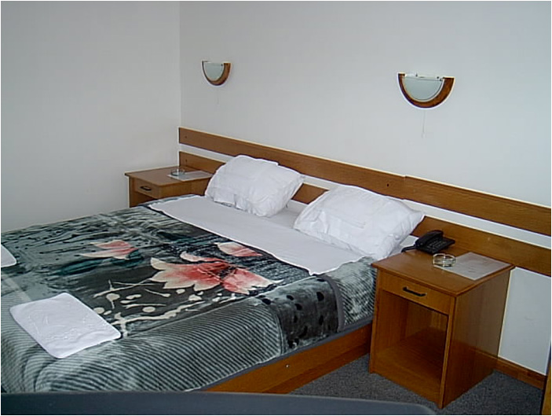
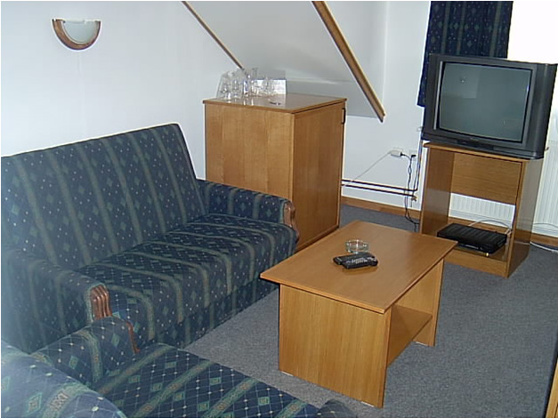
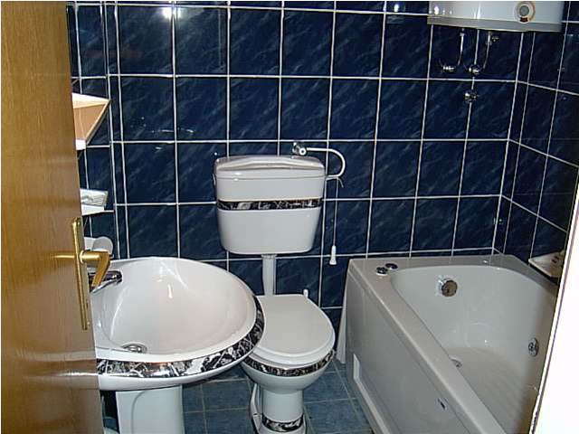
STUR BARKA
surbarka@ptt.yu

BARKA konak is located on the outskirts of Nis - Knjaževac di- rection at 300 meters from the pool. It has a large nice garden and a pleasant ambiance. The hotel has a two banquet halls with total capacity of 1200 seats, and is suitable for all types of celebrations, conferences, lectures and
cultural events. It is located near the city pool and is suitable for sports teams in the preparatory activities. Unspoiled nature of Stara Planina and hunting grounds in the vicinity of Knjaževac are a paradise for hunters. BARKA Residence offers comfortable accommodation. BARKA Residence has 142 beds in rooms with telephone, TV with satellite channels, fridge and bathroom, as well as 5 suites with Jacuzzi tub. The guest house is located in billiards, table tennis room and a modern gym.

ADDITIONAL DELEGATES AND SUPORTERS: A special package has been arranged by the Organizing Committee as follows: 2-night hotel accommodations, including 2-night hotel accommodations (May 10th and 11th) in double room, with breakfast, lunch packet at venue site, banquet, tickets for the Prejudging/Finals and Farewell Banquet on May11th and Breakfast on May 12th.The price of this package is EUR €100 in a double room per person. This package will also apply to journalists and photographers and can be purchased upon arrival.

HOTEL DEPOSITS: An initial deposit of EUR €50 per person is required upon check-in for incidental and personal expenses which may arise (telephone, mini-bar, laundry, room service, etc.). The unused portion of this deposit will be refunded at check-out. In order to facilitate matters, the chief delegate or team leader will be asked to provide a credit card or cash to cover the deposit for the entire team. This individual will be fully responsible for all expenses incurred by any member of his team.
PLEASE INFORM YOUR ATHLETES BEFORE DEPARTURE NOT TO CREATE ADDITIONAL EXPENSES FOR YOUR FEDERATION.

Venue site: Knjaževac Sports Hall Kaplar Knjazevac,Lole Ribara 12
The SeventhIFBB Balkan Cup will take place in Knjaževac S.Hall Kaplar.
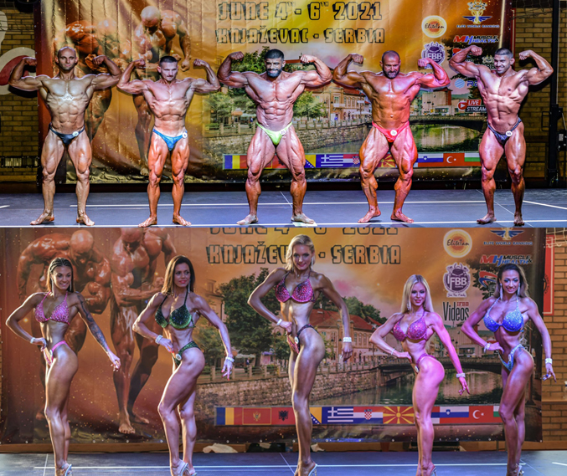
IMPORTANT ARRIVAL AND CHECK- IN NOTICES COMPETITOR NOTIFICATION
Once the Entry Form from a National Federation has been received and accepted, an official e-mail will be sent confirming your participation in the 2024 IFBB Seventh Open Balkan Cup and Third Kid’s Fitness International Gold Grand Prix.
We strongly encourage you to register early and make the appropriate arrangements to compete in the event in Knjaževac.
CATEGORIES FOR THE IFBB SEVENTH BALKAN CUP:
 | DISCIPLINE | CATEGORY
1 | Men’s Bodybuilding | Up to & including 70 kg
2 | Men’s Bodybuilding | Up to & including 80 kg
3 | Men’s Bodybuilding | Up to & including 90 kg
4 | Men’s Bodybuilding | Up to & including 100 kg
5 | Men’s Bodybuilding | Over 100 kg
6 | Men’s Bodybuilding | OVERALL: 1 PRO CARD
7 | Master Men’s Bodybuilding 40 - 49 years: | 1 open category
8 | Master Men’s Bodybuilding >50 years: | 1 open category
9 | Master Men’s Bodybuilding | Overall
10 | Junior Men’s Bodybuilding 16-23 years | Up to 75 kg
11 | Junior Men’s Bodybuilding 16-23 years | Over 75 kg
12 | Junior Men’s Bodybuilding | Overall
13 | Men’s Classic Bodybuilding* | Up to & including 175 cm
14 | Men’s Classic Bodybuilding* | Over 175 cm
15 | Men’s Classic Bodybuilding* | OVERALL
16 | Masters Classic Bodybuilding >40 years* | 1 open category
17 | Men’s Physique | Up to & including 170 cm
18 | Men’s Physique | Up to & including 176 cm
19 | Men’s Physique | Up to & including 182 cm
20 | Men’s Physique | Over 182 cm
21 | Men’s Physique | OVERALL: 1 PRO CARD
22 | Juniors Men’s Physique 16-23 years | 1 open category
23 | Masters Men’s Physique >40 years | 1 open category
24 | Muscular Men’s Physique | 1 open category
25 | Men’s Classic Physique** | 1 open category
26 | Women’s Bodyfitness | Up to & including 163 cm
27 | Women’s Bodyfitness | Over 163 cm
28 | Women’s Bodyfitness | OVERALL
29 | Master Women’s Bodyfitness >35 years | 1 Open Category
30 | Women’s Bikini | Up to& including 160 cm
31 | Women’s Bikini | Up to & including 164 cm
32 | Women’s Bikini | Up to & including 169 cm
33 | Women’s Bikini | Up to & including 172 cm
34 | Women’s Bikini | Over 172 cm
35 | Women’s Bikini | OVERALL: 1 PRO CARD
36 | Junior Women’s Bikini 16-23 years | 1 open category
37 | Master Women’s Bikini >35 years | 1 open category
38 | Women’s Wellness | 1 open category
39 | Women’s Fit Model | 1 open category
40 | Masters Women’s Wellness >35 years | 1 open category
41 | Women’s Physique | 1 Open Category

CATEGORIES OPEN AT FITNESS CHALLENGE SILVER STANDARD, EVENT:
No. | DISCIPLINE | CATEGORY | TEAM
1 | MEN’S FITNESS CHALLENGE (athletes between the age of 24 and 40) | One open class | unlimited
2 | WOMEN’S FITNESS CHALLENGE (athletes between the age of 24 and 35) | One open class | unlimited
3 | MASTER MEN’S FITNESS CHALLENGE (athletes +40 years) | One open class | unlimited
4 | MASTER WOMEN’S FITNESS CHALLENGE (athletes + 35 years | One open class | unlimited

*-Maximum bodyweight limits [in kg] for Men and Masters Classic Bodybuilding:
Up to 168 cm (Athlete’s height [cm] -100) + 0 [kg]
Up to 171 cm (Athlete’s height [cm] -100) + 2 [kg]
Up to175 cm (Athlete’s height [cm] -100) + 4 [kg]
Up to 180 cm (Athlete’s height [cm] -100) + 7 [kg]
Up to 188 cm (Athlete’s height [cm] -100) + 9 [kg]
Up to 196 cm (Athlete’s height [cm] -100) + 11 [kg]
Over 196 cm (Athlete’s height [cm] -100) + 13 [kg]
**-Maximum bodyweight limits [in kg] for Men and Master Classic Physique:
Up to 168 cm: (Athletes height [cm] -100) + 4 [kg]
Up to 171 cm: (Athletes height [cm] -100) + 6 [kg]
Up to 175 cm: (Athletes height[cm] -100) + 8 [kg]
Up to 180 cm: (Athletes height [cm] -100) + 11 [kg]
Up to 188 cm: (Athletes height[cm] -100) + 13 [kg]
Up to 196 cm: (Athletes height [cm] -100) + 15 [kg]
Over 196 cm: (Athletes height[cm] -100) + 17 [kg]
Note: A category will be run only if 5 or more athletes are registered. Otherwise, categories will be combined.

AWARDS
• Winners in each category will be awarded with a trophy, medal and Certificate of Excellence. The others in the first six will receive medals and certificates.
• Overall in each discipline will have a trophy. Three (3) Pro Cards will be awarded to the Overall winners in the Men’s Bodybuilding, Men’s Physique and Bikini Fitness!

PARTICIPATION
The contest is open for IFBB-affiliated National Federations from the Balkans. Participation in this
Competition is unlimited. The IFBB and the organizer will also accept the participation of competitors from outside the Balkan region if their National Federation registers them and the organizer receives the approval of the IFBB for the participation of any competitor who has expressed a desire to participate in the Seventh Open Balkan Cup and Third Kid’s Fitness International Gold Grand Prix.
Registration of athletes will only be considered if they are entered by the National Federation of the athlete by sending the Final Entry Form with their names directly to the Organizer and to the IFBB Tech- nical Committee and IFBB Head Office in Madrid. The final decision to allow an athlete to compete in this event rests with the IFBB.
Please be aware that it is FULL RESPONSIBILITY AND OBLIGATION OF THE NATIONAL FEDERATION to verify if each one of the athletes to be registered on this international event is NOT
suspended or fulfilling any period of ineligibility due to Anti - Doping Rule Violation or any disciplinary
case at national or international level.
It is also the FULL OBLIGATION AND RESPONSIBILITY of a National Federation to MONITOR ALL THE ATHLETES affiliated to this National Federation who are actually fulfilling a period of ineligi- bility due to Anti - Doping Rule Violation or any Disciplinary case, to make sure these athletes WILL NOT REGISTER/COMPETE/OR PARTICIPATE IN ANY CAPACITY in any event either at National or Interna- tional level, Official or Invitational.

REGISTRATION
Official Athlete Registration will be run on Friday, May 26th, 2023, from 15:00 till 21:00 at the venue (Knjaževac Culture Center), Branka Radicevica Street 1.
It is the responsibility of the chief delegate or team leader to make sure that the athletes are on time. Any athletes who are late will not be accepted to participate. All athletes will have to produce their
Passports and IFBB International Cards at the Registration. IFBB International Cards are EUR €40 per year
and are mandatory. Any athlete who has not yet purchased this Card or need to renew his/her Card will have to be paid ONLY at the REGISTRATION that will take place on May 10th, 2024 at the Knjazevac Culture Center, Branka Radicevica Street 1!

All posing music must be on an audio CD only. The posing music must also be at the start of the CD. Each competitor must affix his/her name on the CD for easy identification. The use of profane, vulgar and offensive language is strictly prohibited in the posing music.
Each athlete participating in the event will be provided with a competitor identification card at the
Registration.
This identification card allows daily admission to the venue.

REGISTRATION FEE
The Organizer of the event in Knjazevac will not accept any direct registration from athletes.
This Final Entry Form will only be considered if it is sent by the National Federation of the athlete and directly to the Organizer, IFBB Technical Committee and IFBB Headquarters in Madrid. The final decision to allow an athlete to compete in this event rests with the IFBB.
Registration and accommodation fee of EUR €150 per athlete and delegate will have to be paid ONLY at the REGISTRATION that will take place on May 10th, 2024 at the Knjazevac Culture Center!!
The cost of accommodation is included in the registration fee. The organizer provided double room with breakfast, lunch packet and banquet on May 11th and breakfast on May 12th. Tickets for the Prejudging, Finals and Farewell banquet in Culture Center on May 11th are included in the registration fee.
Athletes wishing to compete in more than one category will have to pay an extra fee of EUR €50 per each
of the additional categories. Possible crossover: juniors and masters in senior classes, also
Classic Bodybuilding - Classic Physique - Bodybuilding, Bikini - Fit- Model, Wellness - Fit-Model.
This Registration and accommodation Fees are completely separate from the Hotel Deposit mentioned above.
CORRESPONDENCE/CONTACT INFORMATION

PLEASE SEND ALL FINAL ENTRY FORMS AND CORRESPONDENCE TO:
apolon1975knjazevac@gmail.com, and info@ifbb.com and amichalak5@gmail.com
CONTACT PHONE NUMBER: +381 69 155 0974 (Milan Vuckovic)
The contest is open for all IFBB-affiliated Balkan National Federations. Participation in this
Competition is unlimited.
Registration of athletes will only be considered if they are entered by the National Federation of the athlete by sending the Final Entry Form with their names directly to the IFBB Technical Committee, IFBB Head Office and to the Organizing Committee. The final decision to allow an athlete to compete in this event rests with the IFBB.
Please be aware that it is FULL RESPONSIBILITY AND OBLIGATION OF THE NATIONAL FEDERATION to verify if each one of the athletes to be registered on this international event is NOT sus- pended or fulfilling any period of ineligibility due to Anti - Doping Rule Violation
or any disciplinary case at national or international level.
It is also the FULL OBLIGATION AND RESPONSIBILITY of a National Federation to MON- ITOR ALL THE ATHLETES affiliated to this National Federation who are actually fulfilling a period of ineligibility due to Anti - Doping Rule Violation or any Disciplinary case, to make sure these athletes WILL NOT REGISTER/COMPETE/OR PARTICIPATE IN ANY CAPACITY in any event either at National or
International level, Official or Invitational.

Visas:
A valid passport is required to enter Serbia. Citizens of 72 countries don’t need visa to enter Serbia up to 90 days. Detailed information for each country available here: http://www.mfa.gov.rs/en/consular-af- fairs/entry-Serbia/visa-regime
For more information contact the Serbian Embassy in your country, please.
An Official Letter of Invitation will be made available if required.
It is National Federations responsibility to obtain an entry visa for the country organizing the Championship. All National Federations could ask for an Invitation letter either to the
Competition Organizer or IFBB. The invitation letter does not mean you are granted your visa. IFBB and Competition Organizer are not responsible of attendant’s visas. To receive invitation letter, the applicant should forward a copy (scan) of passport to the IFBB or Competition Organizer.
If the visa is not granted, the Cancellation Policies for the championship will still apply.
An athlete, who requested and received an invitation from the IFBB Head Office or the Organizing, Committee of an IFBB sanctioned event for visa purposes and used this visa to unlawful stay in the host country or any other country, will be subjected to the disciplinary proceedings and measures.

Official language:
The official language is Serbian, but English is widely used. The staff of hotels, travel agencies
and shops with who the visitors will be in contact will speak English.

Time difference:
The time in Knjaževac is UTC+2 (Central European Summer Time Zone)

Currency:
The official currency in Serbia is Serbian Dinar (RSD) 1 EUR = 117 RSD (as for January 2023).
Current rates at: https://www.xe.com/currency/rsd-serbian-dinar/

Climate:
During May the weather is sunny and warm. The average temperature is 22˚C.

Electric Current:
220 V, 50 Hz, plugs/sockets of type C and F (two round prongs) Airport arrivals:
The Organizing Committee will organize your transport from Belgrade, Sofia or Niš International Airports at your arrival. It is very important that every Federation provides their details to the Organizing Committee, including the number of people in their delegation. Your cooperation is essential in order to ensure adequate transportation of your team.
Transport from airports: Transport from the Nikola Tesla Airport, Belgrade (300 km away from Knjaževac) will be provided by the organizer: we will have 8 passenger vans waiting for you. Transportation price depends on number of passengers per van:
7 or 8 passengers – EUR €55 per person – two way ticket
6 passengers – EUR €60 per person – two way ticket
5 passengers – EUR €75 per person – two way ticket
4 passengers – EUR €90 per person – two way ticket
3 passengers – EUR €125 per person – two way ticket
Transportation price if you are arriving on the Sofia Airport, Bulgaria (170 km away from
Knjaževac):
7 or 8 passengers – EUR €30 per person – two way ticket 6 passengers – EUR €35 per person – two way ticket
- passengers – EUR €45 per person – two way ticket
4 passengers – EUR €50 per person – two way ticket
3 passengers – EUR €70 per person – two way ticket
Nikola Tesla Airport, Belgrade, and Sofia Airport, Bulgaria are international airports and as such should cover destinations all over the world.
Transportation price if you are arriving at the airport in Nis (65 km away from Knjaževac ):
7 or 8 passengers – EUR €13 per person – two way ticket
- passengers – EUR €15 per person – two way ticket
5 passengers – EUR €20 per person – two way ticket
4 passengers – EUR €25 per person – two way ticket
3 passengers – EUR €33 per person – two way ticket
Niš Constantine the Great Airport has regular air traffic from the following destinations:
Basel, Switzerland
Malmö, Sweden Dortmund, Germany Berlin, Germany
Istanbul, Turkey
Transport request needs to be send to email:
apolon1975knjazevac@gmail.com
Passport/Music:
All competitors must provide their passports and music (on audio CD, with one track) at weigh-in,
failing which the competitor will not be registered and will not be allowed to compete.. Parade of Nations:
All delegates are reminded that the dress code for the Parade of Nations is the official IFBB uniform.

Judges:
To be taken into consideration during selection of judges panels at the competition, IFBB Interna- tional Judges (as well as test - judges) must be included in the Final Entry Forms sent by National Federa- tions.
For more information, please contact Mr. Pawel Filleborn, Chairman of the IFBB Judges Commit- tee, under address: pawelfilleborn@gmail.com
IFBB International Judges must have a valid IFBB Judge’s Card with the IFBB yearly judge’s fee of EUR €50 paid for 2023.
All judges must be present at the Team Managers and Judges Meeting. Any judge absent at this
Meeting will not be allowed to judge at this competition.
If any of the above conditions hasn’t been met, judges will be unable to carry out their duties at the competition.

National Flags:
All National Federations are reminded to bring their National Flags for use in the Victory Ceremony.

National Anthem:
All participating National Federations must bring the music of their national anthem on a CD with them to Knjazevac. This must be on a separate CD to any posing music.

Backstage Access/Dressing room access:
Access to the backstage area/dressing room shall be strictly limited to the essential personnel only.
Coaches and trainer who assist athletes in the dressing room must be of the same sex as the athlete they are assisting.
Cameras/Videotapes:
Cameras and videotapes shall be strictly prohibited in the backstage area/dressing room except when used by dully recognized press personal and in any event, this device shall be strictly prohibited in the dressing room/backstage area.
TANNING
THE IFBB HAS BANNED ALL TANS THAT CAN BE WIPED OFF. AN OFFICIAL WILL CHECK THE TAN OF ALL ATHLETES BACKSTAGE AND IF THE TAN COMES OFF BY SIMPLY WIP- ING, THE ATHLETE WILL BE TOLD TO REMOVE THE TAN BEFORE GOING ON STAGE.

Press accreditation:
Any press representatives that wish to obtain press accreditation for this event have to register upon arrival and contact the Organization Committee.

Official Athlete Registration:
Official Athlete Registration will take place in the Knjaževac, Culture Center, Branka Radicevica 1, Knjaževac, on May 10th, from 15:00 till 21:00. It is the responsibility of the chief delegate or team leader to make sure that the athletes are on time. Any athletes who are late will not be accepted to participate.

Secretariat:
The Organizing Committee will have a desk in the lobby of the Knjazevac Culture Center on
May 10th and 11th, 2024. You may obtain information and assistance from the Secretariat when required.

Flight reconfirmation:
For the reconfirmation of your flight, you may seek the assistance of the Secretariat. Please recon- firm your flight upon arrival at the Knjaževac Culture Center, to avoid last minute problem.

Entry Forms:
Please return the Final Entry Form with the names of the members of your team NO LATER THAN May, 8th, 2024. Please indicate the category of your athletes in the Final Entry Form. Your co-operation is essential to ensuring your accommodations at the Hotels, and assuring adequate transportation for your team.
PLEASE TAKE NOTE: All National Federations that do not advise in advance about their extra
delegates and supporters to the Organizing Committee may have a risk to find out that the Hotel has no rooms available, due to its limited capacity. PLEASE NOTIFY THE ORGANIZING COMMITTEE ABOUT THE NUMBER OF YOUR EXTRA DELEGATES / SUPPORTERS.

Please send all correspondence to:

Organizing Committee
Mr. Milan Vucković,
E-mail: apolon1975knjazevac@gmail.com
Cell: + 381 69 155 0 974 ,

IFBB Technical Committee
Eng. Andrew Michalak
E-mail: amichalak5@gmail.com

IFBB Head Office:
Ms. Daria
E-mail: contact@ifbb.com

Consequences of failure to cooperate with the contest organizer:
Failure to cooperate with the contest organizer is contrary to the IFBB code of Ethics and will result in the offending national federation having to pay all of their expenses, with no guarantee of accommodation at the official hotel. If the preliminary and/or the final entry form is not submitted on time to the organizing committee the double amount of the participation fee will be charged as a fine to the offending national federation.
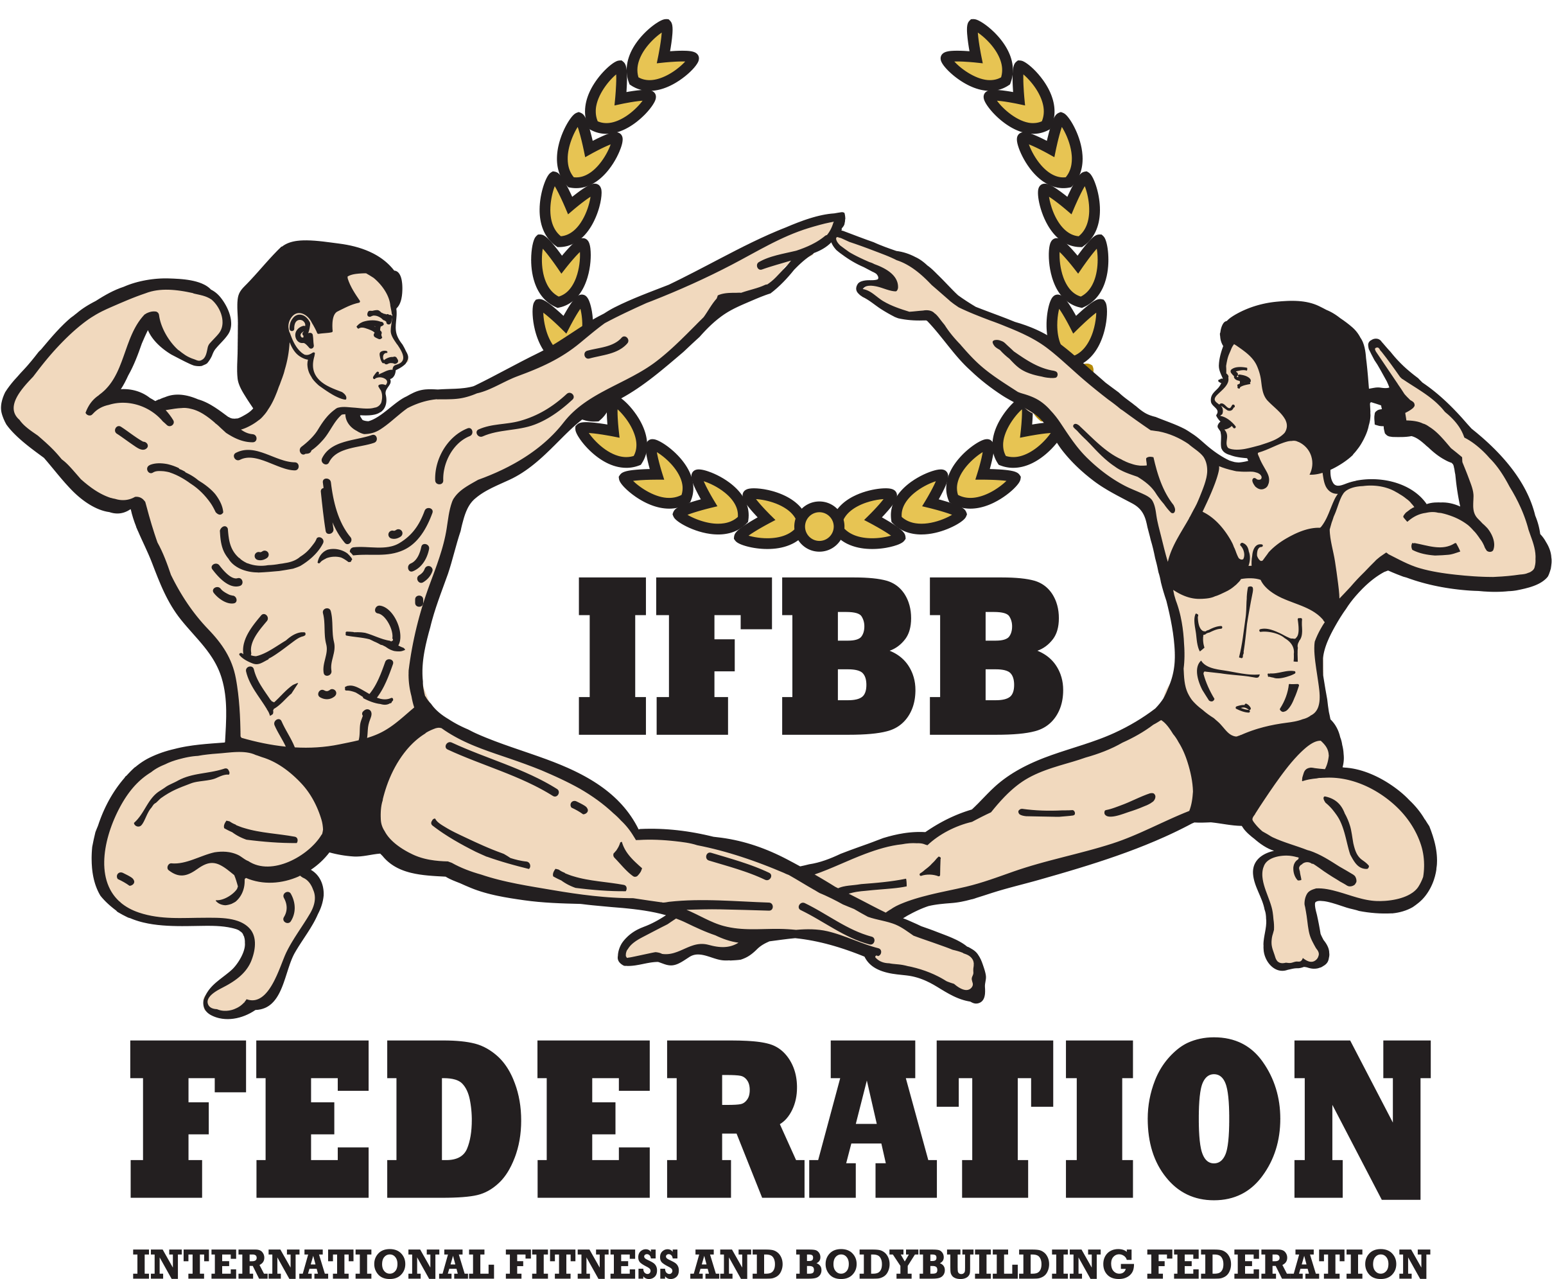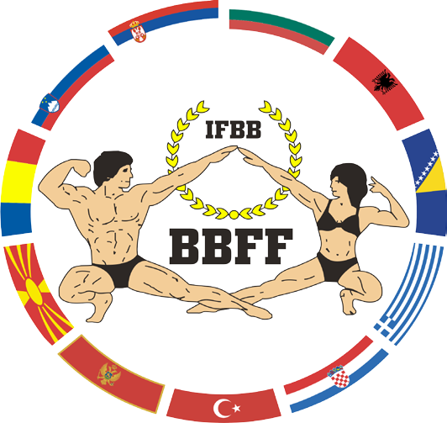

TENTATIVE SCHEDULE OF ACTIVITIES

- The following schedule of activities is tentative and is therefore subject to change.
Please check regularly for updates.
May 10th sport activity (registration&weigh-in) will be held at the Knjaževac Culture Center,
Branka Radicevica Str, 1
May 11th sport activity (Championships, award ceremony
Prejudging and Finals) will be held at the Knjazevac

Sports Hall „Kaplar“ Lole Ribara 12

Friday, May 10th, 2024
08:00 – 16:00: Arrival of National Teams and check-in – Knjaževac Culture Center
15:00 – 21:00: Official Athlete Registration (weigh-in) – Knjaževac Culture Center
16:00 – 17:00: Team Managers & Judges Meeting – Knjaževac Culture Center

Saturday, May, 11th, 2024
07:00 – 09:00: Breakfast in the hotel where you are accommodated
11:00 - 14:00: Kid’s and Senior Fitness Challenge and Kid’s Fitness
Prejudging and Finals – Knjazevac Sports Hall „Kaplar“
14:00 – 14:30: Lunch at the Sports Hall „Kaplar“
16:30 – Opening of the Championships, award ceremony
Prejudging and Finals - Sports Hall „Kaplar“
22:00: Farewell Banquet in the Knjaževac Culture Center

Sunday, May, 12th, 2024
7:30 – 10:00: Breakfast
10:00 – 12:00: Departures of delegations

