International Fitness & Bodybuilding Federation
Dublin 39/I – Europolis – Las Rozas - Madrid – 28232 – Spain - Tel: (34) 5352819
E-mail: headquarters@ifbb.com Website: www.ifbb.com

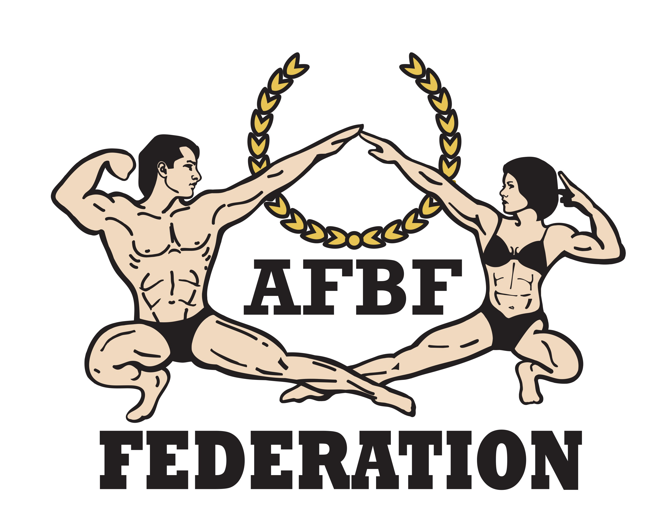


FINAL ENTRY FORM

Deadline date to send this Final Entry Form is Monday, July 22nd, 2024
2024 IFBB MR. UNIVERSE JORDAN
August 01st to 04th, 2024
AMMAN – JORDAN
IFBB WORLD RANKING EVENT LEVEL 3; ELITE PRO QUALIFIER (12 PRO CARDS)
This Entry Form is to be completed and sent by National Federations, NOT by individual athletes.
It is full responsibility and obligation of the National Federation to verify if each one of the athletes to be registered on this international event are NOT SUSPENDED or fulfilling any period of ineligibility due to Anti-Doping Rule Violation or any disciplinary case at national or international level.

COUNTRY |  | NATIONAL FEDERATION’S NAME |  |  |  | NF PRESIDENT’S NAME
FEDERATION’S CONTACT NO. (OFFICE OR CELL PHONE) |  |  |  | NATIONAL FEDERATION’S E-MAIL ADDRESS
 | If applicable: Responsible Delegate(s) name at this event |  |  |  | Cell phone |  | PASSPORT No.
1
2
Complete this Form in English Letters and leave it in the WORD format, so we can copy/paste the athletes’ names on our list. DO NOT change it to PDF format, please.
 | Competitor’s  1 Given NAME + 1 Family NAME |  | EXACT CATEGORY  (from the list of available categories below) |  |  |  | IFBB IC or  PASSPORT No.
1
2
3
4
5
6
7
8
9
10
11
12
13
14
15
16
17
18

IF YOU HAVE MORE ATHLETES, CONTINUE THIS TABLE, PLEASE.

This Final Entry Form will only be considered if it is sent by the National Federation of the athlete and directly to the Organizing Committee, IFBB Head Office in Madrid and IFBB Technical Committee (see e-mail addresses below). The final decision to allow an athlete to compete in this event rests with the IFBB.

Registration Fee for athletes is USD $200 if paid not later than July 23rd, 2024, 23:59. If paid at the Registration in Amman it will be USD $250.

Fees have to be paid online on the IFBB webpage: http://www.ifbb.com/competition-registration. Please add your
name during online payment and bring a copy of your payment confirmation to the registration.
Crossovers: an extra fee of USD $100 per each of the additional categories will be charged.
Possible crossovers: Classic Bodybuilding – Classic Physique – Bodybuilding. Also junior and masters in senior classes.

CATEGORIES OPEN AT THE 2024 IFBB MS. UNIVERSE JORDAN
Men Bodybuilding  Up to & incl. 65 kg  Up to & incl. 70 kg  Up to & incl. 75 kg  Up to & incl. 80 kg  Up to & incl. 85 kg  Up to & incl. 90 kg  Over 90 kg  OVERALL (Elite Pro Cards for the top 2)  Junior Men Bodybuilding 16-23 years:  Up to & incl. 75 kg  Over 75 kg  Master Men Bodybuilding  40-44 yrs. – OPEN  ≥45 yrs. – OPEN  OVERALL (Elite Pro Card for the winner)  Men Classic Physique*  Up to & incl. 170 cm  Up to & incl. 174 cm  Up to & incl. 178 cm  Over 178 cm  OVERALL (Elite Pro Cards for the top 2)  Junior Men Classic Physique 16-23 yrs. – OPEN*  Master Men Classic Physique  Age 40-44: open  Age ≥45: open | Men Classic Bodybuilding*  Up to & incl. 170 cm  Up to & incl. 174 cm  Up to & incl. 178 cm  Over 178 cm  OVERALL (Elite Pro Cards for the top 2)  Junior Men Classic Bodybuilding 16-23 yrs. – OPEN*  Master Men Classic Bodybuilding >40 yrs. – OPEN*  Men’s Physique  Up to & incl. 170 cm  Up to & incl. 173 cm  Up to & incl. 176 cm  Up to & incl. 179 cm  Over 179 cm  OVERALL (Elite Pro Cards for the top 3)  Junior Men’s Physique 15-23 yrs.  Up to & incl. 174 cm  Up to & incl. 178 cm  Over 178 cm  Master Men’s Physique  Age 40-44:open  Age 45-49:open  Age ≥50: open  Muscular Men’s Physique  Up to 174 cm  Up to 178 cm  Over 178 cm  OVERALL (Elite Pro Cards for the top 2)

Note 1: A category will only be run if 3 or more athletes are registered. Otherwise, categories will be combined.
Note 2: *- Categories with weight / height limits

Please list your IFBB INTERNATIONAL JUDGES coming to this event:
 | NAME OF JUDGE(S) - (AS WRITTEN IN PASSPORT) | PASSPORT NUMBER
1
2
3
Please list your TEST- JUDGES names here:
 | NAME OF TEST- JUDGE(S) - (AS WRITTEN IN PASSPORT) | PASSPORT NUMBER
1
2
3

EXTRA DELEGATES AND SUPPORTERS
 | Extra Delegates or Supporters | If a Judge please  V |  | Extra Delegates or Supporters | If Judge please  V
1 |  |  | 6
2 |  |  | 7
3 |  |  | 8
4 |  |  | 9
5 |  |  | 10

Note, please, that each National Federation wishing to participate in these Championships must have paid the IFBB (EUR €500) affiliation fee for 2023. Otherwise, this Federation will not be allowed to participate. This fee should be paid in no later than March 01st of each year. Paying after March 01st, it will be EUR 800 (IFBB).

Please send Entry Form no later than Monday, July 22nd, 2024 to:  Organizing Committee  Mr. Muzamil Abdul Hameed  E-mail: info@goldeninnovations.ae  IFBB Technical Committee  Eng. Andrew Michalak  E-mail: amichalak5@gmail.com | Please send a copy to:  International Fitness & Bodybuilding Federation  Head Office:  Ms. Daria  E-mail: contact@ifbb.com

Date of issue:

Completed by (your name & position in the NF):

