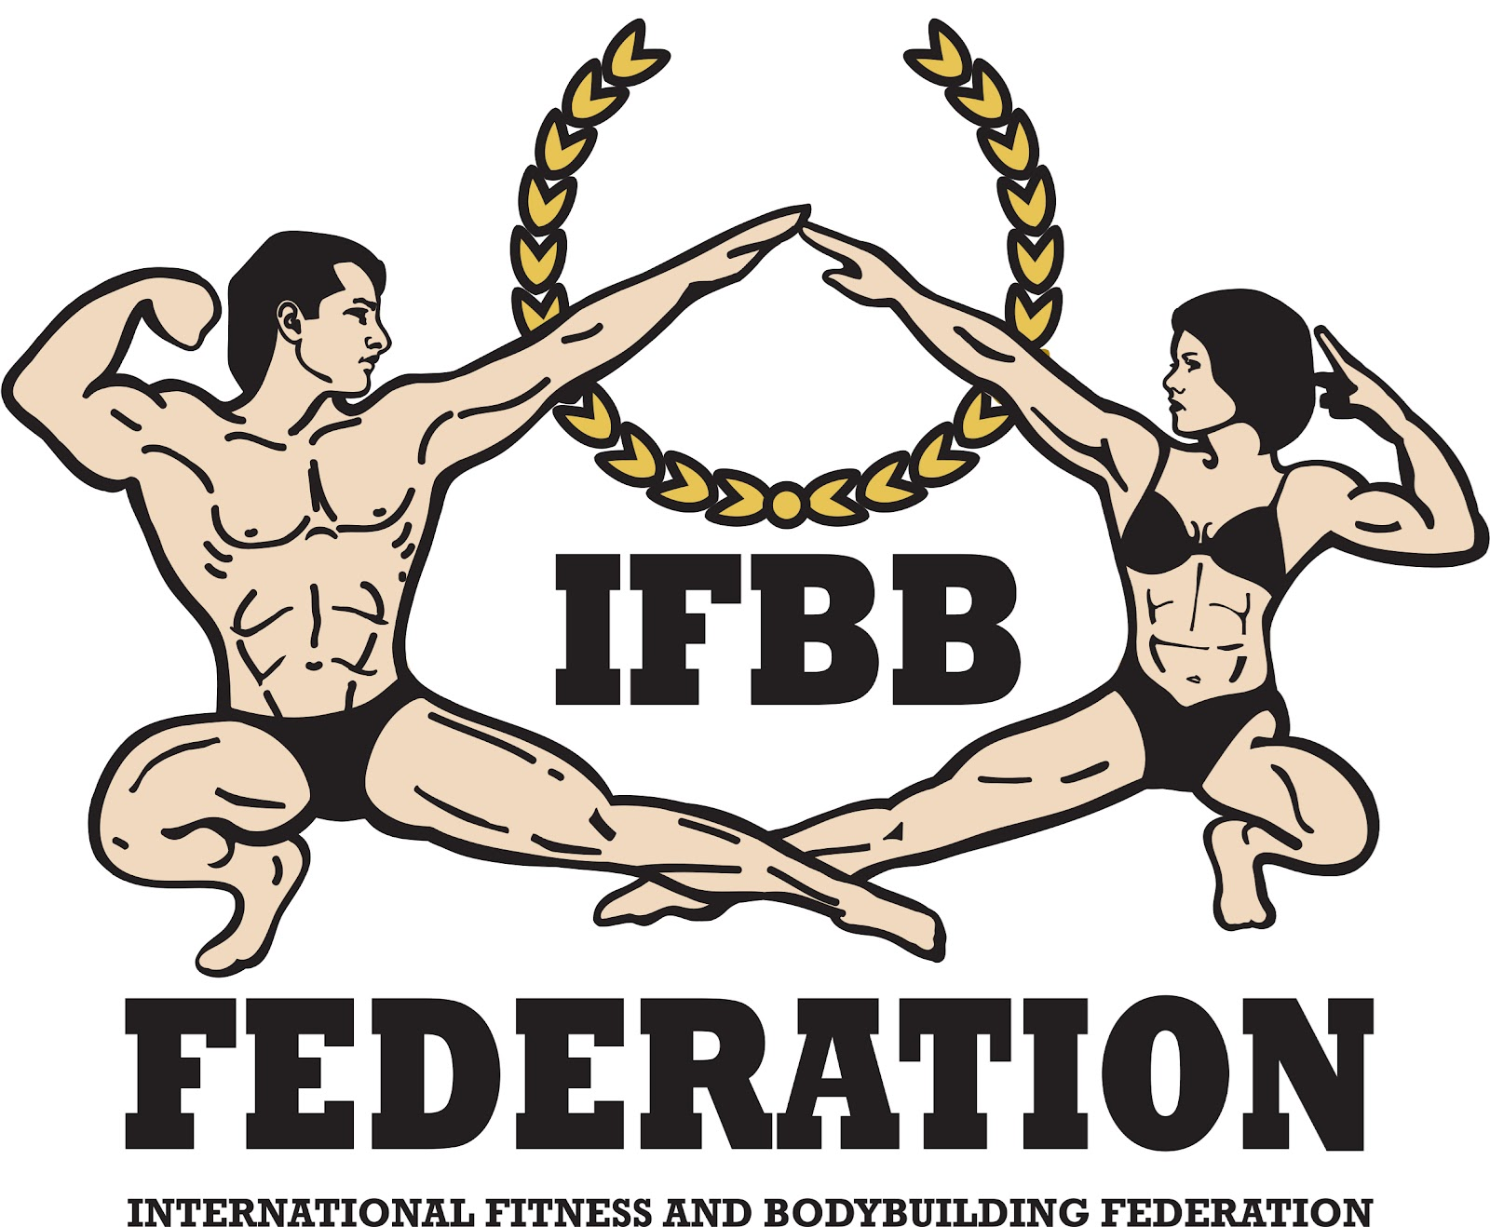

International Fitness & Bodybuilding Federation
Dublin 39/I – Europolis – Las Rozas - Madrid – 28232 – Spain - Tel: (34) 5352819
E-mail: headquarters@ifbb.com Website: www.ifbb.com

FINAL ENTRY FORM

2025 IFBB WORLD MEN’S BODYBUILDING CHAMPIONSHIPS
2025 IFBB MEN’S FIT-MODEL WORLD CUP
2025 IFBB WORLD MEN’S & WOMEN’S FITNESS CHALLENGE CHAMPIONSHIPS
2025 IFBB INTERNATIONAL CONGRESS
November 27th to December 01st, 2025; KHOBAR, SAUDI ARABIA
IFBB PRO QUALIFIER
Deadline to send this Final Entry Form is Monday, October 27th, 2025
This Entry Form is to be completed and sent by National Federations, NOT by individual athletes
Please notice that sending this FEF is MANDATORY.
It is full responsibility and obligation of the National Federation to verify if each one of the athletes to be registered on this international event are NOT SUSPENDED or fulfilling any period of ineligibility due to Anti-Doping Rule Violation or any disciplinary case at national or international level.

COUNTRY |  | NATIONAL FEDERATION’S NAME |  |  |  | NF PRESIDENT’S NAME
FEDERATION’S CONTACT NO. (OFFICE OR CELL PHONE) |  |  |  | NATIONAL FEDERATION’S E-MAIL ADDRESS
 | If applicable: Responsible Delegate(s) name at this event |  |  |  | Cell phone |  | PASSPORT No.
1
2
Complete this Form in English Letters and leave it in the WORD format, so we can copy/paste the athletes’ names on our list. DO NOT change it to PDF format, please.
 | Competitor’s  1 Given NAME + 1 Family NAME |  | EXACT CATEGORY  (from the list of available categories below) |  |  |  | IFBB IC or  PASSPORT No.
1
2
3
4
5
6
7
8
9
10
11
12
13
14
15
16
17
18
19
20
21
22

IF YOU HAVE MORE ATHLETES, CONTINUE THIS TABLE, PLEASE.

This Final Entry Form will only be considered if it is sent by the National Federation of the athlete and directly to the Organizing Committee, IFBB Head Office in Madrid and IFBB Technical Committee (see e-mail addresses below). The final decision to allow an athlete to compete in this event rests with the IFBB.

Registration Fee for athletes, official delegates, extra delegates and supporters is EUR €600 in a double room or EUR €700 in a single room (including 4-day accommodation + 3 meals per day + local transport).
Fees have to be paid online on the IFBB webpage: http://www.ifbb.com/competition-registration. Please add your
name during online payment and bring a copy of your payment confirmation to the registration. The online payment system will be switched off on Tuesday, November 18th, 23:59 (midnight, CET = UTC +1). If paying after this date or at the Registration in Saudi Arabia on November 27th, 2025, an extra fee of EUR €50 per participant will be charged.
Fees may also be paid via bank transfer to the following account:
Beneficiary: FEDERACION INTERNACIONAL DE CULTURISMO Y FITNESS
Bank: BBVA; Account No: ES51 0182 6127 1102 0158 4781; SWIFT: BBVAESMMXXX

Crossovers: an extra fee of EUR €100 per each of the additional categories will be charged.
Possible crossovers: Games Classic Bodybuilding - Classic Bodybuilding – Fit Classic Physique – Fit Bodybuilding; Men’s Physique – Men’s Fit-Model; Also juniors and masters in senior classes.

The IFBB is a signatory to the WADA Code. Doping control will be conducted by the IFBB Medical Commission pursuant to the IFBB Anti-Doping Rules, using a WADA accredited laboratory. In order to compete in the championships, each athlete will be required to pay the Anti-Doping Fee of EUR €50. This fee is mandatory and may be paid online, together with the Registration Fee (altogether EUR 650) or at the registration in Iran.
Please list your IFBB INTERNATIONAL JUDGES coming to this event:
 | NAME OF JUDGE(S) - (AS WRITTEN IN PASSPORT) | PASSPORT NUMBER
1
2
3
4

Please list your TEST- JUDGES names here:
 | NAME OF TEST- JUDGE(S) - (AS WRITTEN IN PASSPORT) | PASSPORT NUMBER
1
2
3
4

FIT BODYBUILDING  Junior Men Bodybuilding  15-20 yrs: up to & incl. 75 kg  15-20 yrs: over 75 kg  21-23 years: up to & incl. 75 kg  21-23 years: over 75 kg  Men Fit Bodybuilding  Up to & incl. 170 cm  Up to & incl. 178 cm  Over 178 cm  Master Men Bodybuilding*  Age 40-49: open  Age ≥50: open  Men Wheelchair Bodybuilding  One open class  FIT CLASSIC PHYSIQUE  Men Fit Classic Physique*  Up to & incl. 168 cm  Up to & incl. 171 cm  Up to & incl. 175 cm  Up to & incl. 180 cm  Over 180 cm  Master Men Fit Classic Physique*  40-49 years: open  50 years & over: open | GAMES CLASSIC BODYBUILDING  Junior Games Classic Bodybuilding*  15-20 years: open  21-23 years: open  Men Games Classic Bodybuilding*  Up to & incl. 171 cm  Up to & incl. 180 cm  Over 180 cm  Master Games Classic Bodybuilding*  Age ≥40: open  CLASSIC BODYBUILDING  Junior Men Classic Bodybuilding*  15-20 years: open  21-23 years: open  Men Classic Bodybuilding*  Up to & incl. 164 cm  Up to & incl. 168 cm  Up to & incl. 171 cm  Up to & incl. 175 cm  Up to & incl. 180 cm  Over 180 cm | MEN’S PHYSIQUE  Junior Men’s Physique  15-17 years: open  18-20 years: open  21-23 years: up to & incl. 174 cm  21-23 years: up to & incl. 178 cm  21-23 years: over 178 cm  Men’s Physique  Up to & incl. 170 cm  Up to & incl. 173 cm  Up to & incl. 176 cm  Up to & incl. 179 cm  Up to & incl. 182 cm  Over 182 cm  Muscular Fit Men’s Physique  One open class  WORLD CUP  Junior Men Fit-Model  15-23 years: open  Men Fit-Model  Up to 176 cm  Up to 183 cm  Over 183 cm  Master Men Fit-Model ≥40 yrs  One Open Class
CATEGORIES OPEN AT THE 2025 WORLD BODYBUILDING CHAMPIONSHIPS – SAUDI ARABIA

Note 1: A category will only be run if 5 or more athletes are registered. Otherwise, categories will be combined.
Note 2: * - Categories with weight / height limits

POSSIBLE CROSSOVERS:
- GAMES CLASSIC BODYBUILDING - CLASSIC BODYBUILDING – FIT CLASSIC PHYSIQUE – FIT BODYBUILDING (BY HEIGHT)
- MEN’S PHYSIQUE – MEN’S FIT-MODEL

SPEED FIT / FITNESS CHALLENGE CATEGORIES:
Only one individual crossover and one collective crossover (pairs or teams) are allowed*

Gold Level
1. Junior (16–23 yrs) – Women's Fitness Challenge (Individual)
2. Junior (16–23 yrs) – Men's Fitness Challenge (Individual)
3. Men's Fitness Challenge (Individual / Men’s & Mixed Couples)
4. Women's Fitness Challenge (Individual / Women’s & Mixed Couples)
5. Master (Over 40 yrs) – Women's Fitness Challenge (Individual)
6. Master (Over 40 yrs) – Men's Fitness Challenge (Individual)

Silver Level
7. Junior (16–23 yrs) – Women's Fitness Challenge (Individual)
8. Junior (16–23 yrs) – Men's Fitness Challenge (Individual)
9. Men's Fitness Challenge (Individual / Men’s & Mixed Couples)
10. Women's Fitness Challenge (Individual / Women’s & Mixed Couples)
11. Master (Over 40 yrs) – Women's Fitness Challenge (Individual)
12. Master (Over 40 yrs) – Men's Fitness Challenge (Individual)

Bronze Level
13. Women's Fitness Challenge (Individual)
14. Men's Fitness Challenge (Individual)
TEAMS:
15. Speed-Fit Team Men
16. Speed-Fit Team Women
17. Team Fitness Challenge Mixed (4 athletes) - Silver level

EXTRA DELEGATES AND SUPPORTERS
 | Extra Delegates or Supporters | If a Judge please  V |  | Extra Delegates or Supporters | If Judge please  V
1 |  |  | 11
2 |  |  | 12
3 |  |  | 13
4 |  |  | 14
5 |  |  | 15
6 |  |  | 16
7 |  |  | 17
8 |  |  | 18

ARRIVING / DEPARTURE DETAILS
ARRIVAL DATE | FLIGHT No. | TIME | No. of people | DEPARTURE DATE | FLIGHT No. | TIME | No. of people

ROOMS NEEDED
 | Room type | Name…… | Sharing with ……Name
 | Single
 | Single
 | Single
 | Double
 | Double
 | Double
 | Double
 | Double
 | Double
 | Double
 | Double
 | Double

POSITION | Unite price | Quantity | TOTAL
REGISTRATION FEE FOR DELEGATES & SUPPORTERS – DOUBLE ROOM | €600 |  | €
REGISTRATION FEE FOR DELEGATES & SUPPORTERS – SINGLE ROOM | €700 |  | €
REGISTRATION FEE FOR ATHLETES – DOUBLE ROOM | €600 |  | €
REGISTRATION FEE FOR ATHLETES – SINGLE ROOM | €700 |  | €
ATHLETE’S INTERNATIONAL CARD ANNUAL FEE 2025 (BLUE BOOK) | €40 |  | €
CROSSOVERS (ADDITIONAL CATEGORIES) | €100 |  | €
ANTI-DOPING TEST FEE PER COMPETITOR | €50 |  | €
IFBB AFFILIATION FEE 2025 (IF UNPAID) | €800 |  | €
EXTRA NIGHTS |  |  | €
 |  | TOTAL: | €
SUM UP YOUR NATIONAL TEAM TOTAL FEE, PLEASE

Note, please, that each National Federation wishing to participate in these Championships must have paid the IFBB (EUR €800), if not paid before March 01st, 2025. Otherwise, this Federation will not be allowed to participate.

Please send this Entry Form no later than Monday, Oct. 27th, 2025 to:  Organizing Committee:  Mr. Faris Aldokheel  E-mail: info@sbbf.sa  IFBB Technical Committee  Eng. Andrew Michalak  E-mail: amichalak5@gmail.com | Please send a copy to:  International Fitness & Bodybuilding Federation  Head Office:  Ms. Daria  E-mail: contact@ifbb.com

Date of issue:

Completed by (your name & position in the NF):

