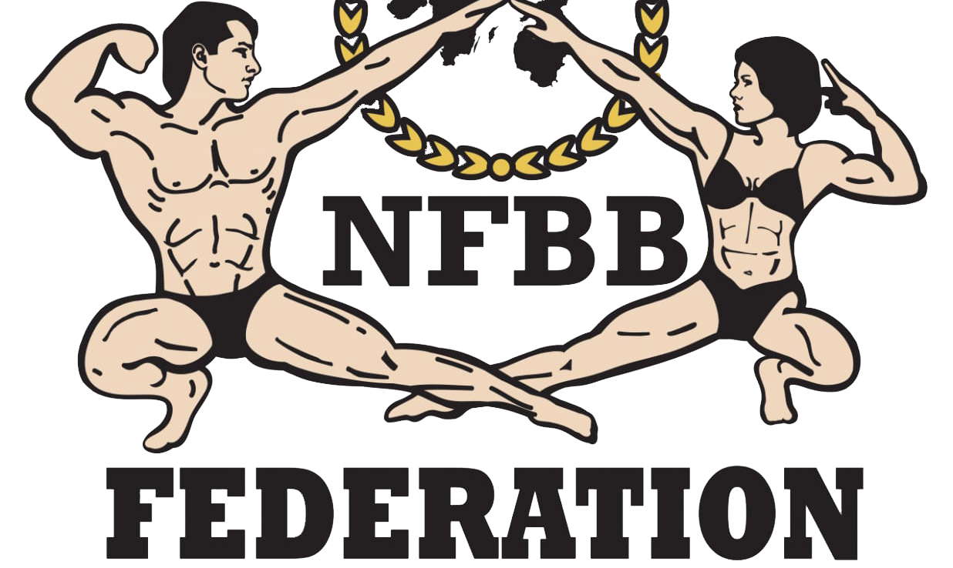
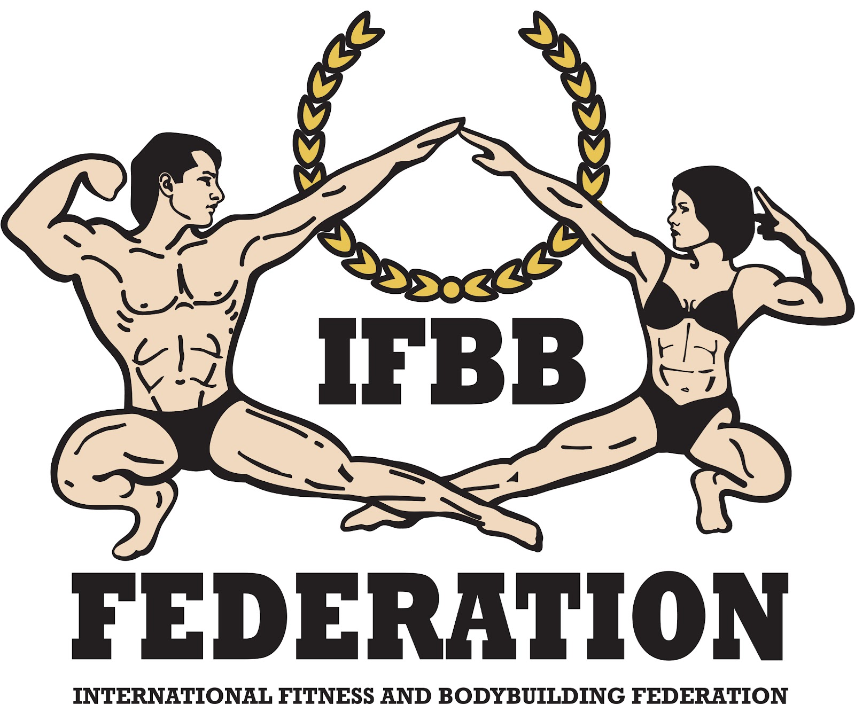

FINAL ENTRY FORM

Deadline date to send the Final Entry Form is Monday, October 13th, 2025
2025 IFBB NORDIC CHAMPIONSHIPS
October 24th – 26th, 2025 – ALINGSÅS, SWEDEN

This Entry Form is to be completed and sent by National Federations, NOT by individual athletes
It is full responsibility and obligation of the National Federation to verify if each one of the athletes to be registered on this international event are NOT SUSPENDED or fulfilling any period of ineligibility due to Anti-Doping Rule Violation or any disciplinary case at national or international level.
COUNTRY |  | NATIONAL FEDERATION’S NAME |  |  |  | NF PRESIDENT’S NAME
NATIONAL FEDERATION CONTACT NO. (OFFICE OR CELL PHONE) |  |  |  | NATIONAL FEDERATION E-MAIL
 | If applicable: Responsible Delegate(s) name at this event |  |  |  | Cell phone |  | PASSPORT No.
1
2
Complete this Form in ENGLISH LETTERS and leave it in the WORD format, so we can copy/paste the athletes’ names on our list. DO NOT change it to PDF format, please.
 | Competitor’s:  1 Given NAME + 1 Family NAME |  | EXACT CATEGORY  (according to the list of categories below) |  |  |  |  | IFBB IC or  PASSPORT NR
1
2
3
4
5
6
7
8
9
10
11
12
13
IF YOU HAVE MORE ATHLETES, CONTINUE THIS TABLE, PLEASE.

The Registration Fee is EUR €150 per athlete and will have to be paid directly in the registration

Additional categories: EUR €50 per each of the additional categories will be charged.
Doping Control fee: EUR €20 per athlete.

Categories accepted at the 2025 IFBB NORDIC CHAMPIONSHIPS:

Saturday, October 25th, 2025:

Women’s Artistic Fitness - OPEN

Women’s Fit-Model - OPEN

Men’s Classic Bodybuilding:
-175 cm

-180 cm

+180 cm

Junior Men’s Classic Bodybuilding 15-23 yrs - OPEN

Master Men’s Classic Bodybuilding:

40 to 49 years

50 years and over

Women’s Bikini:

-160 cm

-164 cm

-168 cm

+168 cm

Junior Women’s Bikini 15-23 yrs - OPEN

Master Women’s Bikini:

35 to 44 years

45 to 49 years

50 years and over

Men’s Physique:
-170 cm

-178 cm

+178 cm

Junior Men’s Physique 15-23 yrs - OPEN

Master Men’s Physique:

40 to 49 years

50 years and over

Fit-Pairs

Sunday, October 26th, 2025:

Women’s Acrobatic Fitness - OPEN

Women’s Physique:

-163 cm

+163 cm

Master Women’s Physique >35 yrs - OPEN

Women’s Bodyfitness:
-163 cm

-168 cm

+168 cm

Junior Women’s Bodyfitness 15-23 yrs - OPEN

Master Women’s Bodyfitness:

35 to 44 years

45 to 49 years

50 years and over

Women´s Wellness:

-164 cm

+164 cm

Junior Women’s Wellness 15-23 yrs - OPEN

Master Women’s Wellness >35 yrs - OPEN

Mixed-Pairs

Men’s Fit Classic Physique
-171 cm

-180 cm

+180 cm

Junior Men’s Classic Physique 15-23 yrs - OPEN

Master Men’s Classic Physique >40 yrs - OPEN

Men’s Fit Bodybuilding - OPEN

-171 cm

-178 cm

+178 cm

Junior Men’s Fit Bodybuilding 15-23 yrs - OPEN

Master Men’s Fit Bodybuilding >40 yrs - OPEN

Note: A category will be run only if 5 or more athletes are registered. Otherwise, categories will be combined.

Please send this Entry Form no later than Monday, October 13th, 2025 to:  Organizing Committee  Promotor: SWEDISH FITNESS FACTORY  Mr. Sharam Daneshmand  Telephone: 0046708902019  E-mail: Shapebysharam@gmail.com  and  SBFF Sweden  E-mail: styrelsen@ifbbsweden.com | Please send a copy to:  IFBB Technical Committee  Eng. Andrew Michalak  E-mail: amichalak5@gmail.com  IFBB Head Office:  Ms. Daria  E-mail: contact@ifbb.com

NOMINATION OF IFBB INTERNATIONAL JUDGES COMING TO THIS EVENT:
 | NAME (AS WRITTEN IN PASSPORT) | PASSPORT NUMBER
1
2
3
4

Date of issue:

Completed by (your name & position in the NF):

