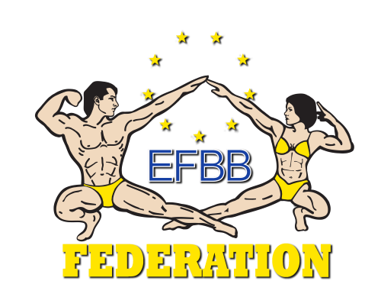
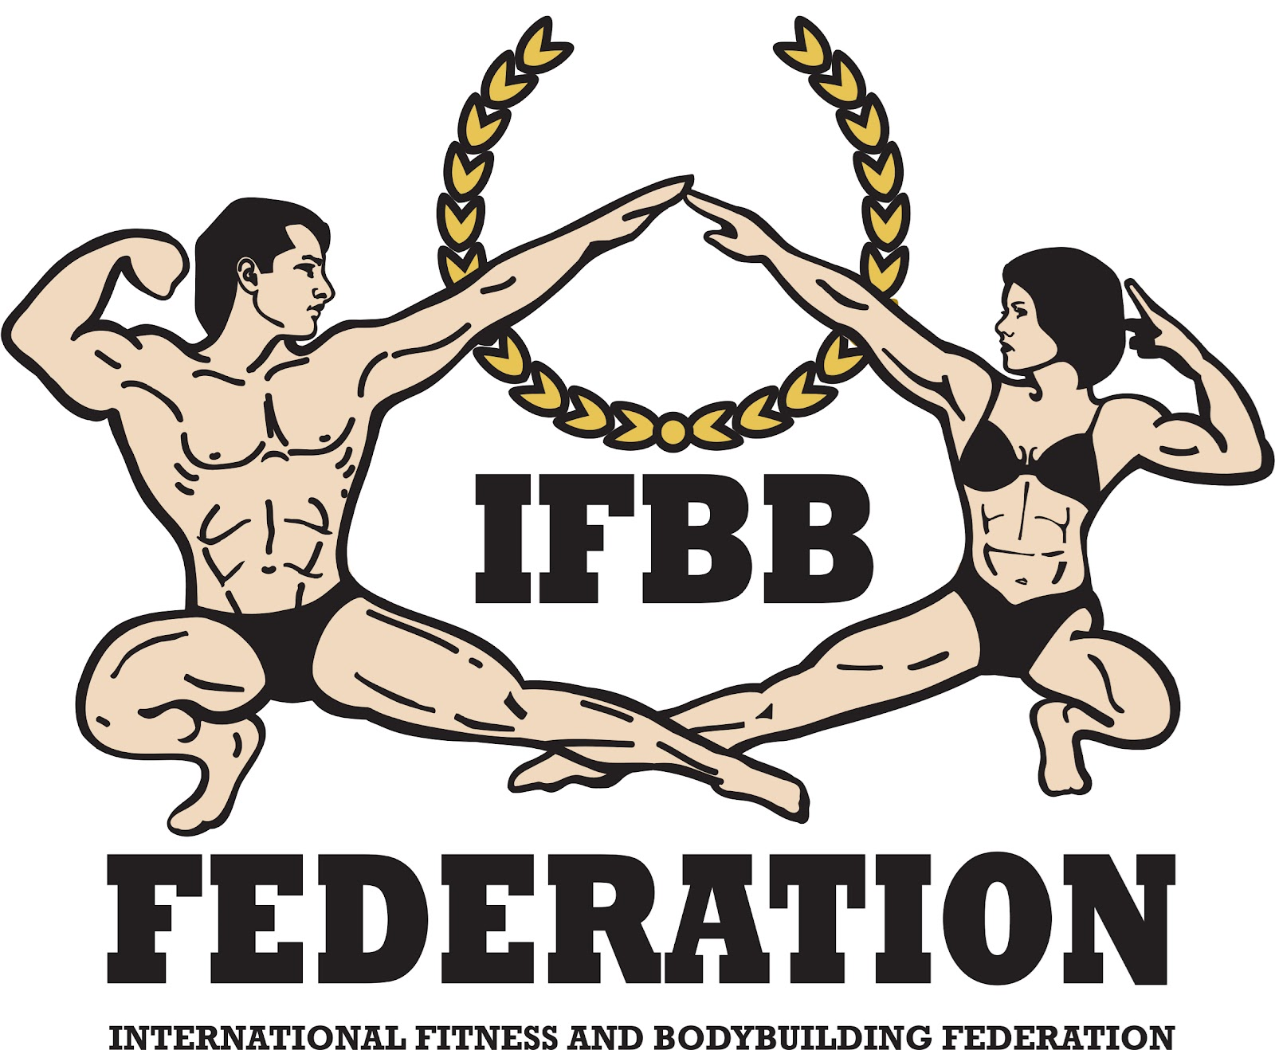

International Fitness & Bodybuilding Federation
Dublin 39/I – Europolis – Las Rozas - Madrid – 28232 – Spain - Tel: (34) 5352819
E-mail: headquarters@ifbb.com Website: www.ifbb.com

FINAL ENTRY FORM

2026 IFBB WORLD BODYBUILDING & FITNESS CHAMPIONSHIPS
2026 IFBB WORLD FITNESS CHALLENGE CHAMPIONSHIPS
2026 IFBB FIT-MODEL WORLD SERIES CUP
October 29th to November 02nd, 2026 - SANTA SUSANNA – SPAIN

Deadline date to send this Final Entry Form is Monday, October 19th, 2026
This Entry Form is to be completed and sent by National Federations, NOT by individual athletes
Please notice that sending this FEF is MANDATORY. Any National Federation attending the event without having previously sent the FEF will be charged with an additional fee of EUR €250.
It is full responsibility and obligation of the National Federation to verify if each one of the athletes to be registered on this international event are NOT SUSPENDED or fulfilling any period of ineligibility due to Anti-Doping Rule Violation or any disciplinary case at national or international level.

COUNTRY |  | NATIONAL FEDERATION’S NAME |  |  |  | NF PRESIDENT’S NAME
 |  |  |  |  |  | Mr./Ms.
FEDERATION’S CONTACT NO. (OFFICE OR CELL PHONE) |  |  |  | NATIONAL FEDERATION’S E-MAIL ADDRESS
 | If applicable: Responsible Delegate(s) name at this event |  |  |  | Cell phone |  | PASSPORT No.
1  2 | Mr./Ms.  Mr./Ms.
Complete this Form in English Letters and leave it in the WORD format, so we can copy/paste the athletes’ names on our list. DO NOT change it to PDF format, please.
 | Competitor’s  1 Given NAME + 1 Family NAME |  | EXACT CATEGORY  (from the list of available categories below) |  |  |  | IFBB IC or  PASSPORT No.
1
2
3
4
5
6
7
8
9
10
11
12
13
14
15
16
17
18
19
20
21
22
23
24

IF YOU HAVE MORE ATHLETES, CONTINUE THIS TABLE, PLEASE.

This Final Entry Form will only be considered if it is sent by the National Federation of the athlete and directly to the Organizing Committee, IFBB Head Office in Madrid and IFBB Technical Committee (see e-mail addresses below). The final decision to allow an athlete to compete in this event rests with the IFBB.

Registration Fee or Special Package for athletes, official delegates, extra delegates and supporters is
- If paid before July 15th, 2026: EUR €540 in a double room or EUR €690 in a single room.
- If paid not later than October 20th, 2026: EUR €600 in a double room or EUR €750 in a single room.
- If paid after October 20th, 2026: EUR €700 in a double room or EUR €850 in a single room.
Crossovers: EUR €100 per each of the additional categories.
Extra night: EUR €70 per person in a double room or EUR €100 per person in a single room.

Fees have to be paid online on the IFBB webpage: http://www.ifbb.com/competition-registration. Please add your
name during online payment and bring a copy of your payment confirmation to the registration. Fees may also be paid via bank transfer to the following account:
Beneficiary: FEDERACION INTERNACIONAL DE CULTURISMO Y FITNESS
Bank: BBVA; Account No: ES5101826127110201584781; SWIFT: BBVAESMMXXX

Possible crossovers: Games Classic Bodybuilding - Classic Bodybuilding – Classic Physique – Bodybuilding; Men’s Fitness – Men’s Physique – Men’s Fit-Model; Women’s Acrobatic Fitness – Women’s Bodyfitness; Women’s Artistic Fitness – Women’s Bikini – Women’s Fit-Model, Women’s Wellness – Women’s Fit-Model. Also junior and masters in senior classes.

DOPING CONTROL: The IFBB is a signatory to the WADA Code. Participating National Federations have a duty and an obligation to ensure that their national team athletes are competing drug-free at the IFBB Championships. Doping control will be conducted by the ITA and IFBB pursuant to the IFBB Anti-Doping Rules, using a WADA accredited laboratory. In order to compete in the championships, each athlete will be required to sign a Drug Testing Consent at the Registration.
Please list your IFBB INTERNATIONAL JUDGES coming to this event:
 | NAME OF JUDGE(S) - (AS WRITTEN IN PASSPORT) | PASSPORT NUMBER
1
2
3
4

Please list your TEST- JUDGES names here:
 | NAME OF TEST- JUDGE(S) - (AS WRITTEN IN PASSPORT) | PASSPORT NUMBER
1
2
3
Junior Men Bodybuilding  15-20 yrs: up to & incl. 75 kg  15-20 yrs: over 75 kg  21-23 years: up to & incl. 75 kg  21-23 years: over 75 kg  Master Men Bodybuilding  40-49 years - open  50 years & over - open  Men Games Classic Bodybuilding*  Up to & incl. 171 cm  Up to & incl. 180 cm  Over 180 cm  Junior Games Classic Bodybuilding*  15-20 years: open  21-23 years: open  Master Games Classic Bodybuilding*  40-44 years - open  45 years & over - open  Men Classic Bodybuilding*  Up to & incl. 164 cm  Up to & incl. 168 cm  Up to & incl. 171 cm  Up to & incl. 175 cm  Up to & incl. 180 cm  Over 180 cm  Men Bodybuilding*  Up to 70 kg  Up to 75 kg  Up to 80 kg  Up to 85 kg  Up to 90 kg  Up to 95 kg  Over 95 kg  Junior Men Classic Bodybuilding*  15-20 years: open  21-23 years: open  Men Fit Classic Physique*  One open class  Junior Men Classic Physique*  15-20 years: open  21-23 years: open  Master Men Classic Physique*  40 years & over - open  Men’s Physique  Up to & incl. 170 cm  Up to & incl. 173 cm  Up to & incl. 176 cm  Up to & incl. 179 cm  Up to & incl. 182 cm  Over 182 cm  FIT- MODEL WORLD SERIES CUP  Women's Fit-Model  Up to & incl. 162 cm  Up to & incl. 166 cm  Up to & incl. 169 cm  Over 169 cm  Junior Women's Fit-Model:  15-20 years: open  21-23 years: open  Master Women’s Fit-Model >35 yrs  One open class  Men's Fit-Model:  One open class  Junior Men's Fit-Model 15-23 years  One open class  Master Men's Fit-Model >40 years:  One open class | Master Men’s Physique >40 years  One open class  Men Wheelchair Bodybuilding  One open class  Women Acrobatic Fitness  Up to & incl. 163 cm  Over 163 cm  Junior Women Acrobatic Fitness  15-20 years: up to & incl. 163 cm  15-20 years: over 163 cm  21-23 years: up to & incl. 163 cm  21-23 years: over 163 cm  Women Artistic Fitness  Up to & incl. 163 cm  Up to & incl. 168 cm  Over 168 cm  Junior Women Artistic Fitness  15-20 years: open  21-23 years: open  Men Fitness  One Open Class  Junior Men Fitness  15-20 years: open  21-23 years: open  Fit-Pairs  One open class  Fit Women’s Physique  One open class  Posing Art  One open class  Junior Men’s Physique  15-17 years: open  18-20 years: open  21-23 years: up to & incl. 174 cm  21-23 years: up to & incl. 178 cm  21-23 years: over 178 cm  Women’s Disabilities–OPEN  Men’s Disabilities–OPEN | Women Bodyfitness  Up to & incl. 158 cm  Up to & incl. 163 cm  Up to & incl. 168 cm  Over 168 cm  Junior Women Bodyfitness  15-20 years open  21-23 years open  Master Women Bodyfitness  35-39 years - open  40-44 years - open  45-49 years - open  50 years & over - open  Women Bikini  Up to & incl. 158 cm  Up to & incl. 160 cm  Up to & incl. 162 cm  Up to & incl. 164 cm  Up to & incl. 166 cm  Up to & incl. 169 cm  Up to & incl. 172 cm  Over 172 cm  Junior Women Bikini  15-20 years: up to & incl. 160 cm  15-20 years: up to & incl. 166 cm  15-20 years: over 166 cm  21-23 years: up to & incl. 160 cm  21-23 years: up to & incl. 166 cm  21-23 years: over 166 cm  Master Women Bikini  35-39 years, up to 164 cm  35-39 years, over 164 cm  40-44 years - open  45-49 years - open  50 years & over - open  Women Wellness  Up to & incl. 158 cm  Up to & incl. 163 cm  Up to & incl. 168 cm  Over 168 cm  Junior Women Wellness  15-20 years: open  21-23 years: up to & incl. 163 cm  21-23 years: over 163 cm  Master Women Wellness  35-39 years - open  40-44 years - open  45-49 years - open  50 years & over - open  Women’s Fit & Beauty  One open class  Men’s Fit  One open class
CATEGORIES OPEN AT THE 2026 WORLD BODYBUILDING & FITNESS CHAMPIONSHIPS:
Note 1: A category will only be run if 5 or more athletes are registered. Otherwise, categories will be combined.
Note 2: *- Categories with weight / height limits

SPEED FIT (FITNESS CHALLENGE) CATEGORIES:
GOLD Women Individual (Seniors + Juniors)
SILVER Women Individual (Seniors + Masters)
BRONZE Women Individual (Seniors)
GOLD Men Individual (Seniors + Juniors)
SILVER Men Individual (Seniors + Masters)
BRONZE Men Individual (Seniors)
GOLD Men Couples
SILVER Women Couples
GOLD/SILVER Mixed Couples
INDIVIDUAL SPEED FIT - 10 REPS x 3 EXERCISES
SPEED FIT TEAMS (Mixed)
CROSSOVERS: In individual categories the crossover is only allowed with individual speed fit.
Crossover between gold/silver/bronze is not permitted.
Crossover between individual/couples/ speed fit teams or speed fit individual: EUR €50.

EXTRA DELEGATES AND SUPPORTERS
 | Extra Delegates or Supporters | If a Judge please  V |  | Extra Delegates or Supporters | If Judge please  V
1 |  |  | 16
2 |  |  | 17
3 |  |  | 18
4 |  |  | 19
5 |  |  | 20
6 |  |  | 21
7 |  |  | 22
8 |  |  | 23
9 |  |  | 24
10 |  |  | 25
11 |  |  | 26
12 |  |  | 27
13 |  |  | 28
14 |  |  | 29
15 |  |  | 30

ARRIVING / DEPARTURE DETAILS
ARRIVAL DATE | FLIGHT No. | TIME | No. of people | DEPARTURE DATE | FLIGHT No. | TIME | No. of people

SUM UP YOUR TEAM’S TOTAL EXPENSE, PLEASE

ROOMS NEEDED
 | Single/Share | Name…… | Sharing with ……Name
 | Single
 | Single
 | Single
 | Single
 | Share
 | Share
 | Share
 | Share
 | Triple
 | Triple
 | Triple

POSITION | Unite price |  | Quantity | TOTAL
REGISTRATION FEE REGULAR PAYMENT (NO LATER THAN OCTOBER 20th, 2026):
ATHELTES / DELEGATES / SUPPORTERS - DOUBLE ROOM |  | €600 |  | €
ATHELTES / DELEGATES / SUPPORTERS - SINGLE ROOM |  | €750 |  | €
REGISTRATION FEE LAST-MINUTE PAYMENT (AFTER OCTOBER 20th, 2026):
ATHELTES / DELEGATES / SUPPORTERS - DOUBLE ROOM |  | €700 |  | €
ATHELTES / DELEGATES / SUPPORTERS - SINGLE ROOM |  | €850 |  | €
IFBB INTERNATIONAL CARD ANNUAL FEE 2026 (BLUE BOOK) |  | €50 |  | €
CROSSOVERS (bodybuilding & fitness per category) |  | €100 |  | €
CROSSOVERS (fitness challenge) |  | €50 |  | €
EBFF AFFILIATION FEE 2026 AFTER THE DEADLINE (01.03.2026) |  | €600 |  | €
IFBB AFFILIATION FEE 2026 AFTER THE DEADLINE (01.03.2026) |  | €800 |  | €
SENDING THE FINAL/PRELIMINARY ENTRY FORM AFTER THE DEADLINE FEE |  | €250 |  | €
EXTRA NIGHTS (double room/per person/per night) |  | €70 |  | €
EXTRA NIGHTS (single room/per night) |  | €100 |  | €
TOTAL: |  |  |  | €

Please send this Entry Form  - no later than Monday, October 19th, 2026, in a regular time  to:  Organizing Committee  E-mail: mmramos0025@gmail.com  and  IFBB Technical Committee  Eng. Andrew Michalak  E-mail: amichalak5@gmail.com | Please send a copy to:  International Fitness & Bodybuilding Federation  Head Office:  Ms. Daria  E-mail: contact@ifbb.com

Note, please, that each National Federation wishing to participate in these Championships must have paid the IFBB affiliation fee for 2026. Otherwise, this Federation will not be allowed to participate. Paying after March 01st, it will be EUR 800 (IFBB) and EUR 600 (EFBB).

Date of issue:

Completed by (your name & position in the NF):

